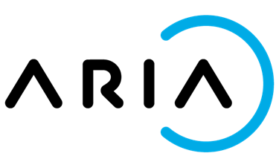

Aria Workflow Test Execution Document for WFINTEL-57(Dunning Notification)

*Prepared By: Chitra Singh*

# Execution Date: 23/06/2022

# Product Build Version: NA

Contents

*Execution Date:23/06/2022* 1

*Product Build Version: NA* 1

UC 01 : As a user when my account Invoice is overdue, an email notification in Standard1 template with details of all open invoices with due amount should be sent to the Statement mail id 3

UC 02 As a user when my Account Invoice is overdue , an automatic email in Standard2 template, with details of all open invoices with due amount should be sent to the statement mail id 6

UC_03 As a user when payment for one the invoice is completed and 2 other invoice is overdue, an email notification in Standard2 template wrt only the open invoices due amount should be sent to the Statement mail id 9

UC 4 : As a user when an account is over due and dunning step is updated to 1 and Dunning template against dunning step 1 is deactivated , Dunning notification mail should not be sent to the customer 12

UC-05 - As a user when my account Invoice is overdue and manual dunning is triggered , an email notification in Standard1 template with details of all open invoices with due amount should be sent to the Statement mail id 14

UC_06 : As a user when my Account Invoice is overdue and manual dunning is triggered , an automatic email in Standard2 template, with details of all open invoices with due amount should be sent to the statement mail id 16

UC-07 - As a user when payment for one the invoice is completed and 2 other invoice is overdue and manual dunning is triggered , an email notification in Standard2 template wrt only the open invoices due amount should be sent to the Statement mail id 20

UC -08 : As a user when my account is over due but in Workflow when I search the related child account to send the email notification , error message should be displayed. 23

Uc-09 : As a user, when I map a template to dunning I should be able to select the template for mapping , against a dunning step . And the new step should be saved in the Mapping list 25

UC-10 : As a user, when I Deactivate a dunning template - Confirmation pop up message should be displayed and Status Active flag should be updated to " FALSE" 26

UC-11 : As a user, when I Activate a dunning template - Confirmation pop up message should be displayed and Status Active should be updated to " TRUE" 28

UC-12 : As a user, when I update a dunning template of a deactivated step by selecting Active check box. Template should be updated to Standard 2 and Active flag to "True" 30

UC-13 : As a user when I delete an existing dunning template , it should be deleted from the list 32

UC-14 : As as user when I deactivate a Master template Standard 1, the active flag should be changed to "False" 33

UC-15 : As as user when I deactivate a Master template Standard 1 and the Standard Template 1 is already in use , warning message should be displayed and template should not be deactivated 35

UC-16 : As as user when I update the Dunning template mapping for a dunning step from Standard 1 to Standard 2(which is deactivated ) , only the active master template should be displayed 36

UC-17 : As a user when I delete an existing template , it should be deleted from the Mater template list 37

UC-18 : As a user when Manual dunning notification is applied , I should be able to fetch the account through Account no. 39

UC-19 : As a user when Manual dunning notification is applied , I should be able to fetch the account through Account name 40

UC-20 : As a user when Manual dunning notification is applied , I should be preview the email template that is selected. 41

# UC 01 : As a user when my account Invoice is overdue, an email notification in Standard1 template with details of all open invoices with due amount should be sent to the Statement mail id

Steps followed :

1. In WFINTEL instance map the dunning step with Standard template1
2. Create an account and invoice (Parent child accounts)

* Invoice created and event 901 is generated.
* There are 3 unpaid Invoices

1. Update the dunning step to 1 in Aria

* Event 744 Dunning Degrade Date Changed will the generated
* Workflow will listen to the event and send an Email notification to customers Statement contact email with list of only unpaid Statements with due amount.
* Dunning notification events notated in Aria account’s comments section
* In WorkFlow Dunning audit log is updated with the Notification ID

Expected Result : Dunning Email notification for the pending invoices should be sent to the Statement contact mail id .

Actual Result : Dunning Email notification only for the pending invoices should be sent to the Statement contact mail id .

Screen shots :

Account # 33040521

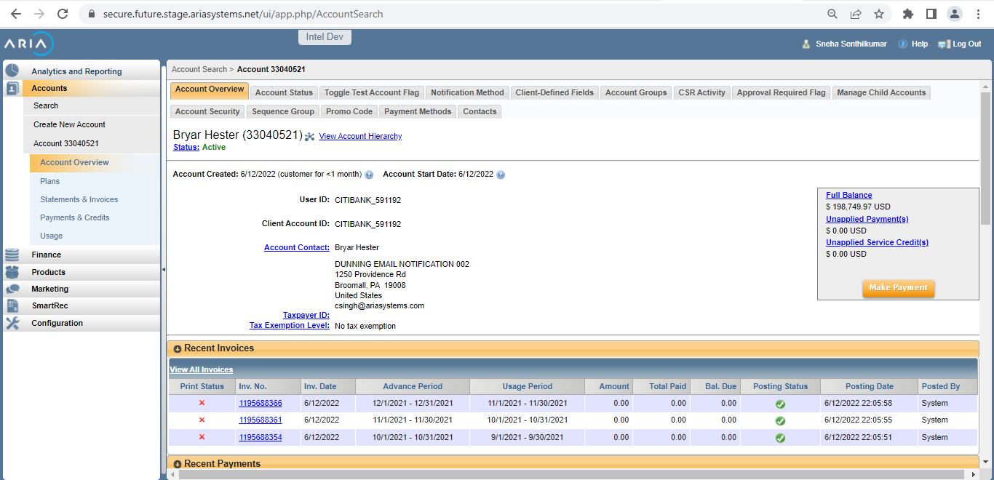

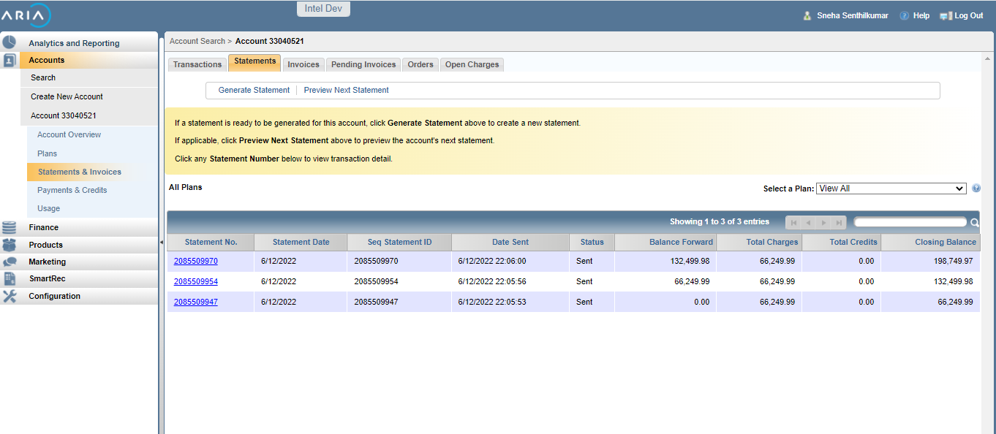

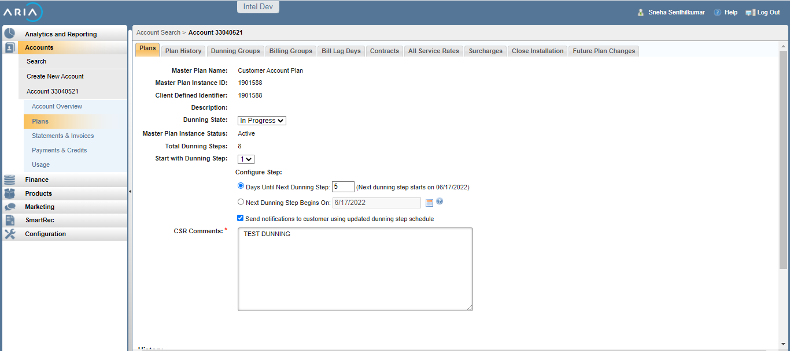

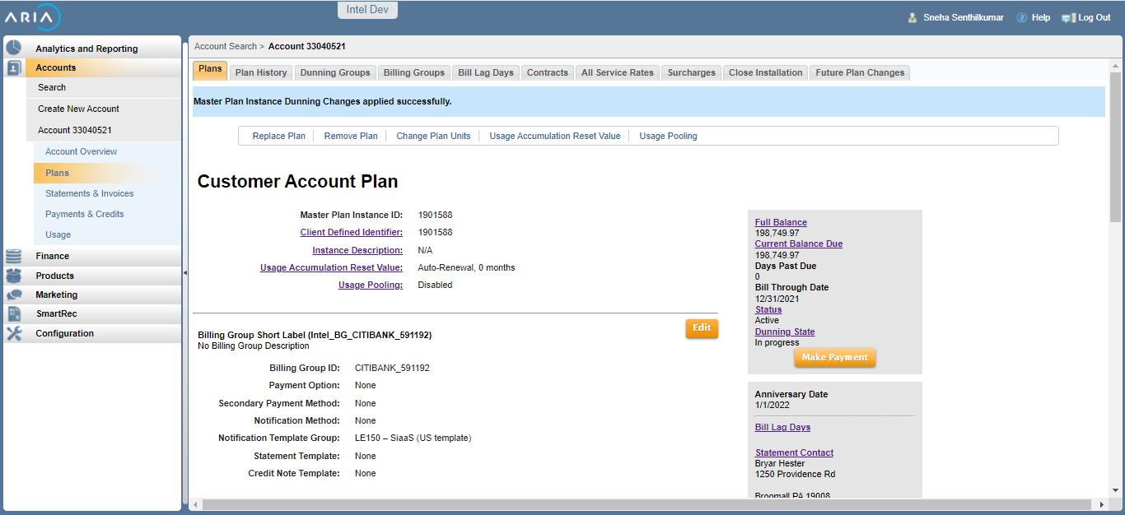

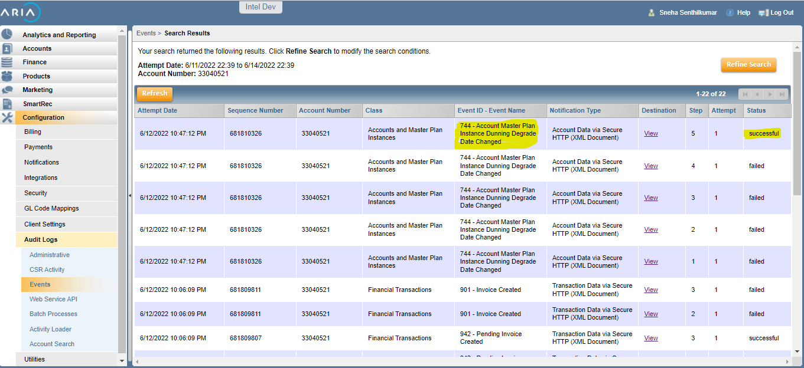

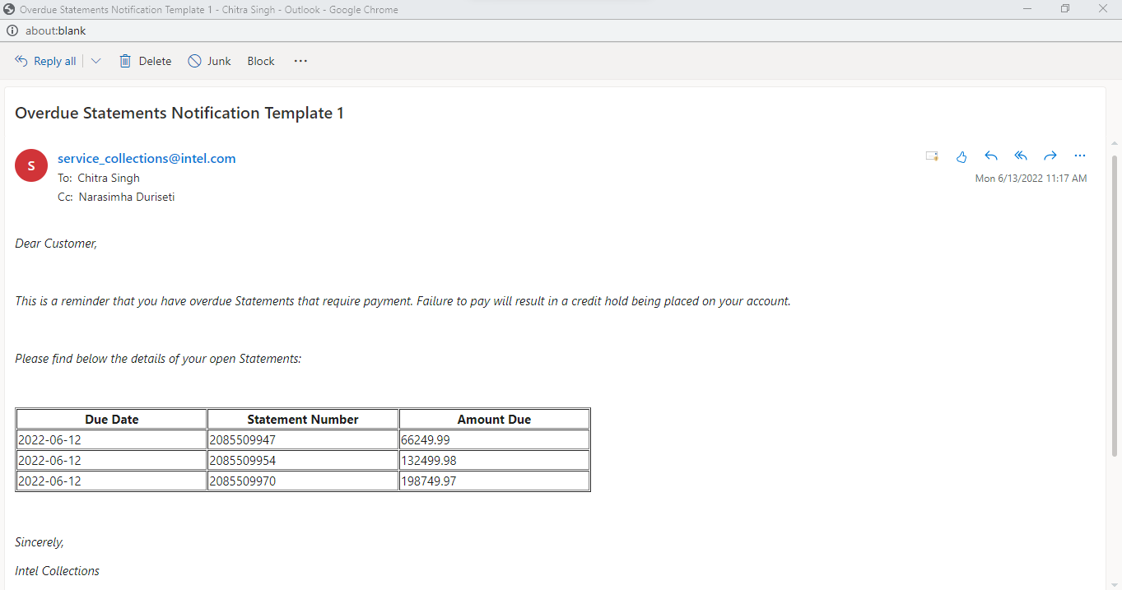

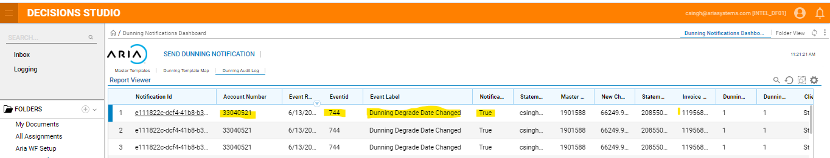

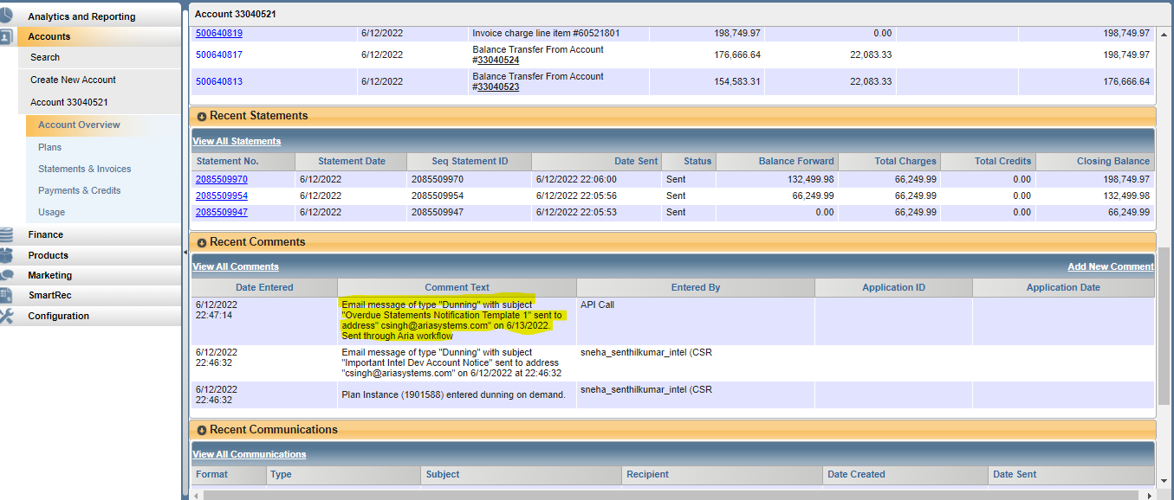

# UC 02 As a user when my Account Invoice is overdue , an automatic email in Standard2 template, with details of all open invoices with due amount should be sent to the statement mail id

Steps Followed :

1. In WFINTEL instance map the dunning step with Standard template2
2. Create an account and invoice (Parent child accounts)

* Invoice created and event 901 is generated.
* There are 3 unpaid Invoices

1. Update the dunning step to 2 in Aria

* Event 744 Dunning Degrade Date Changed will the generated
* Workflow will listen to the event and send an Email notification to customers Statement contact email with list of only unpaid Statements with due amount.
* Dunning notification events notated in Aria account’s comments section
* In Work Flow Dunning audit log is updated with the Notification ID

Expected Result : Dunning Email notification for the pending invoices should be sent to the Statement contact mail id in Standard template 2

Actual Result : Dunning Email notification only for the pending invoices is sent to the Statement contact mail id in Standard template 2

Screen shots :

Account# 33040525

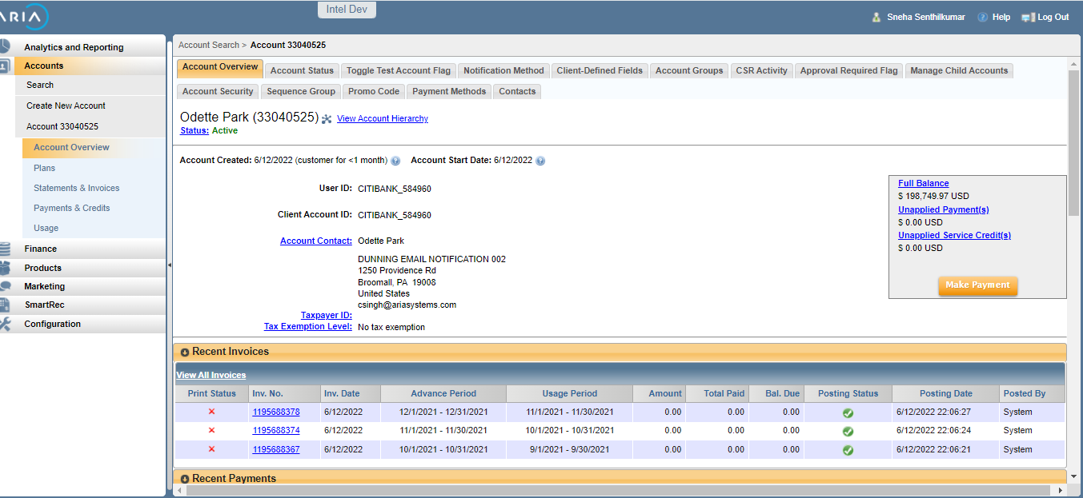

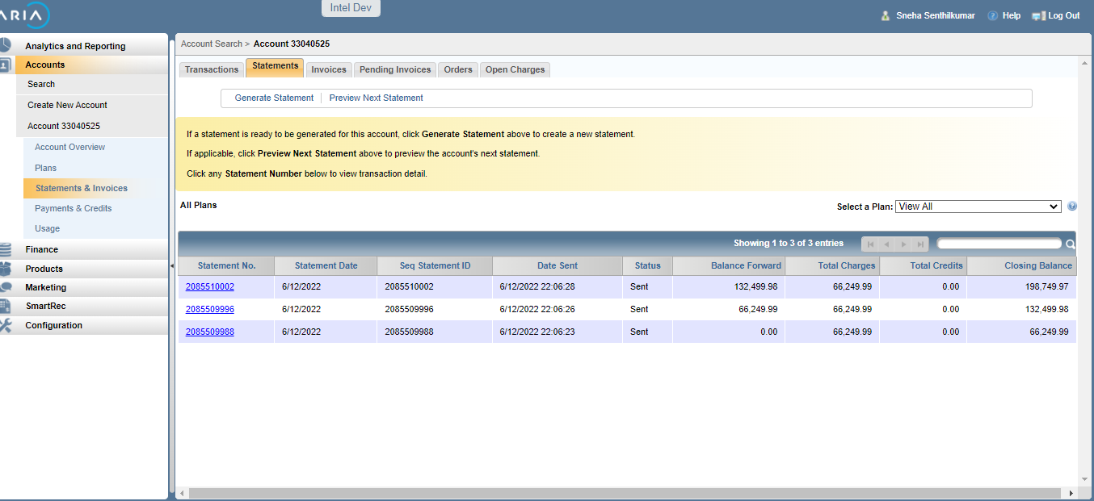

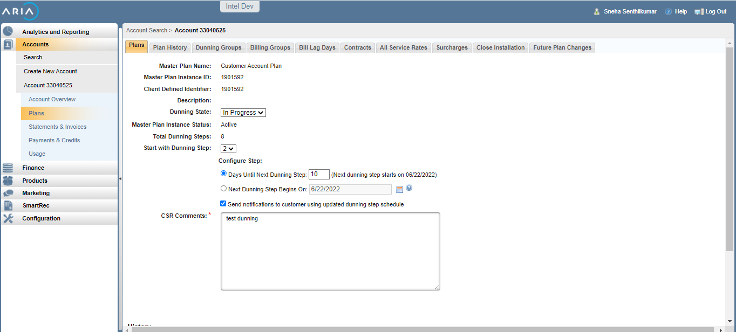

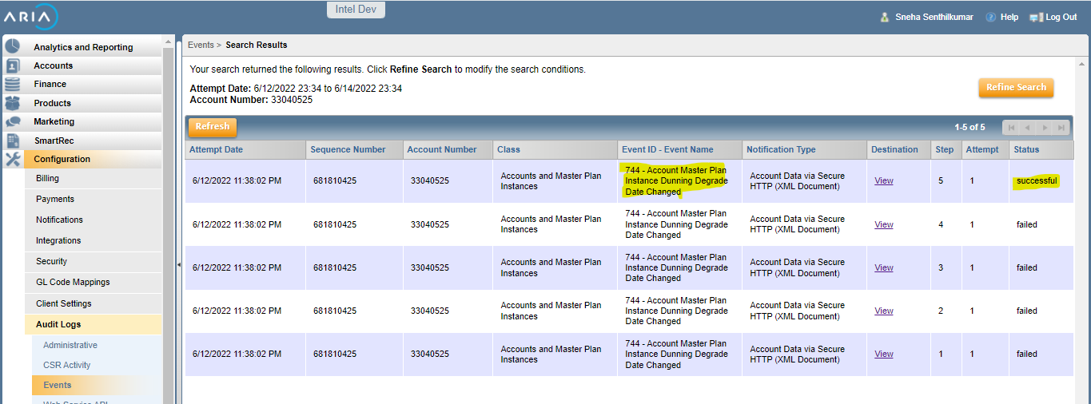

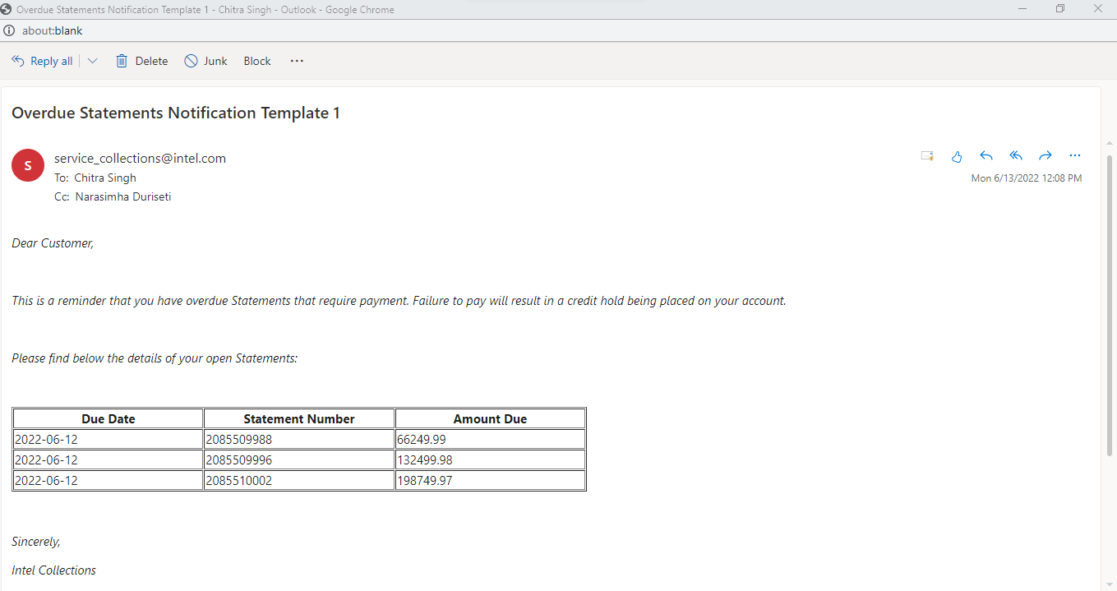

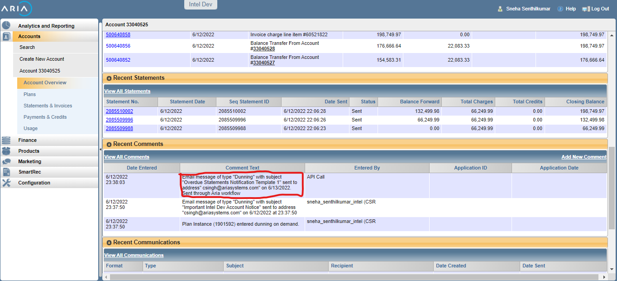

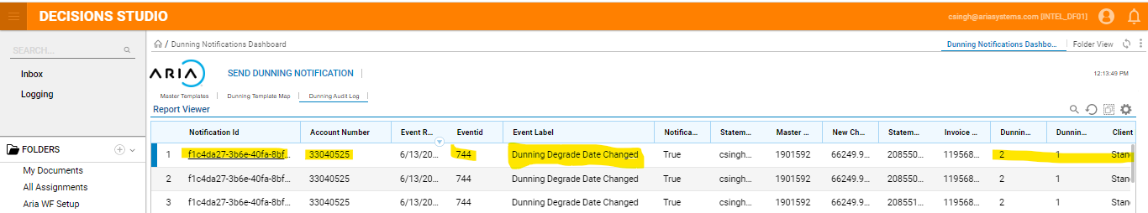

# UC_03 As a user when payment for one the invoice is completed and 2 other invoice is overdue, an email notification in Standard2 template wrt only the open invoices due amount should be sent to the Statement mail id

Steps followed :

1. In WFINTEL instance map the dunning step with Standard template1
2. Create an account and invoice (Parent child accounts)

* Invoice created and event 901 is generated.
* There are 3 unpaid Invoices

1. Apply an external payment (66249.99K)

* Event 903 Check created will be generated

1. Update the dunning step to 1 in Aria

* Event 744 Dunning Degrade Date Changed will the generated
* Workflow will listen to the event and send an Email notification to customers Statement contact email with list of only unpaid Statements with due amount.
* Dunning notification events notated in Aria account’s comments section
* In WorkFlow Dunning audit log is updated with the Notification ID

Expected Result : Dunning Email notification for the unpaid invoices should be sent to the Statement contact mail id .

Actual Result : Dunning Email notification only for the pending invoices is sent to the Statement contact mail id .

Account # 33043116

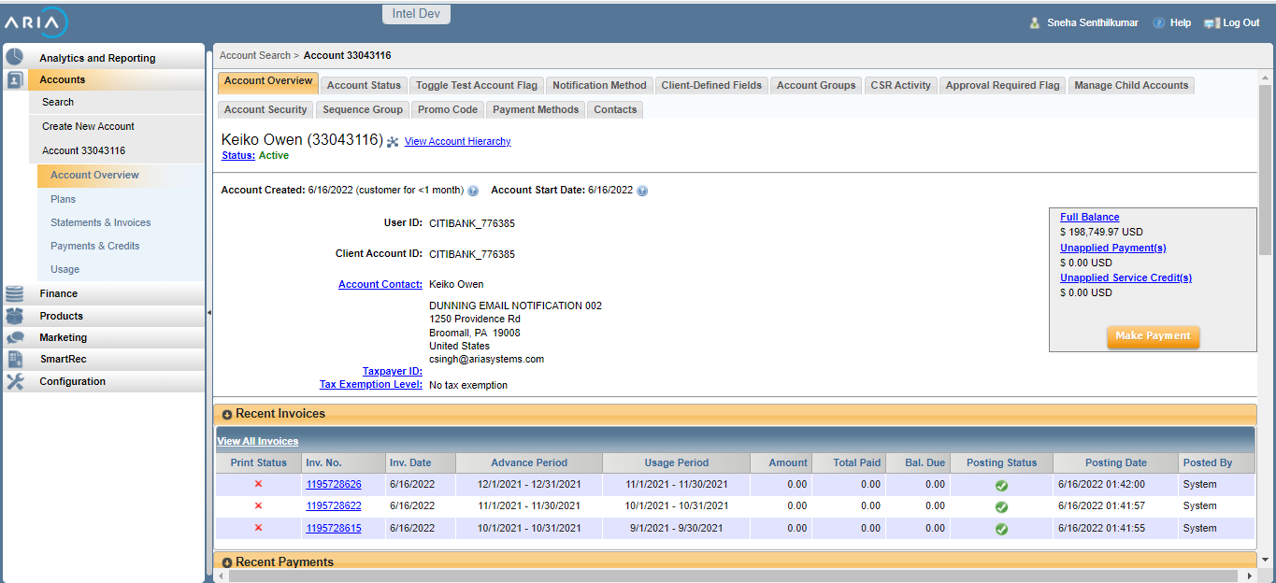

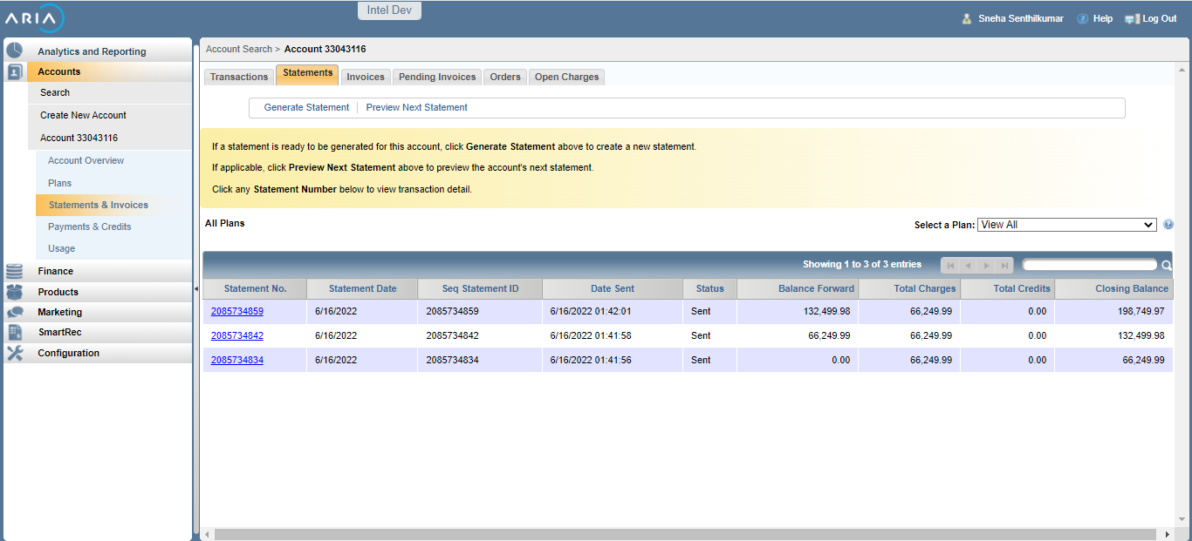

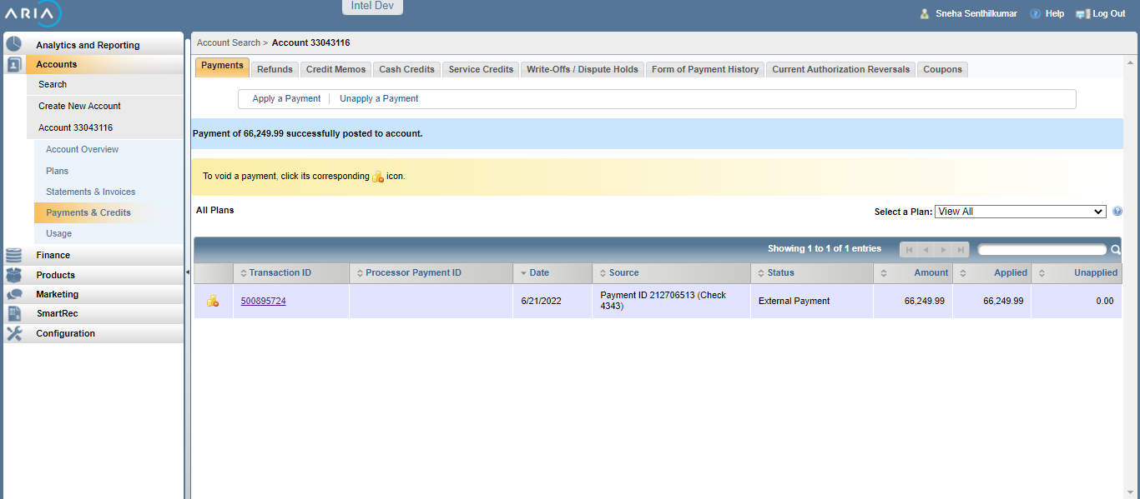

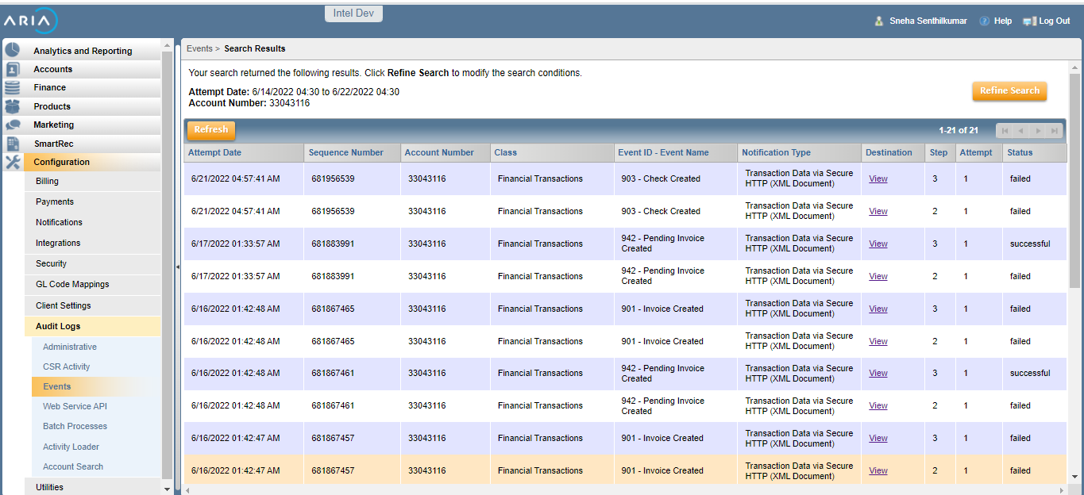

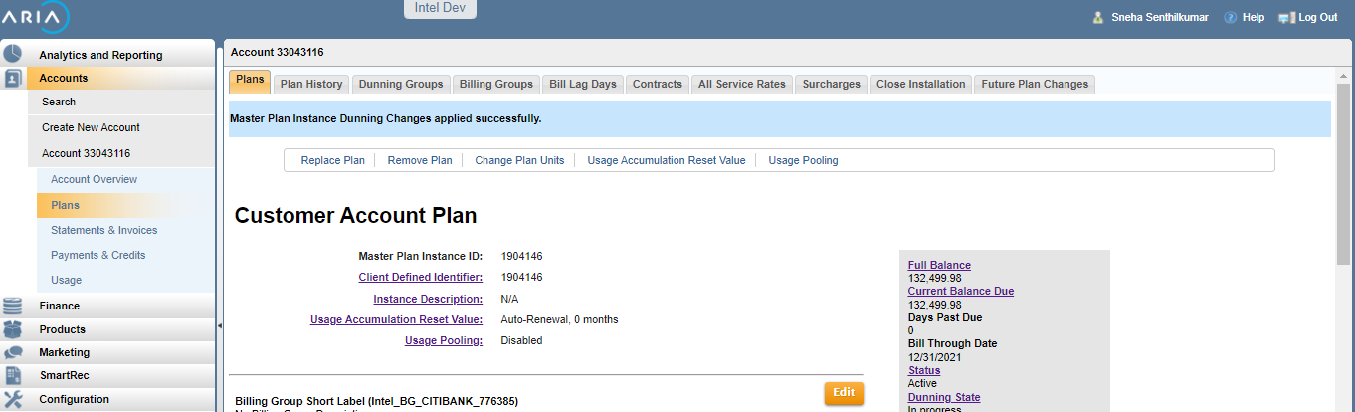

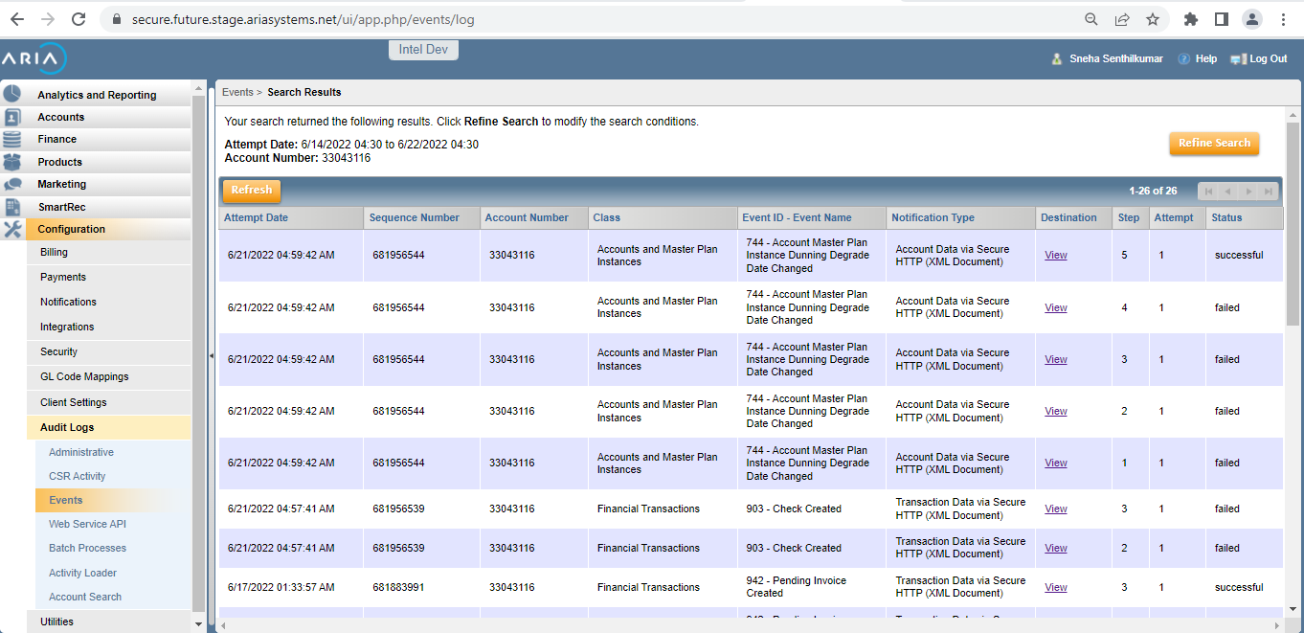

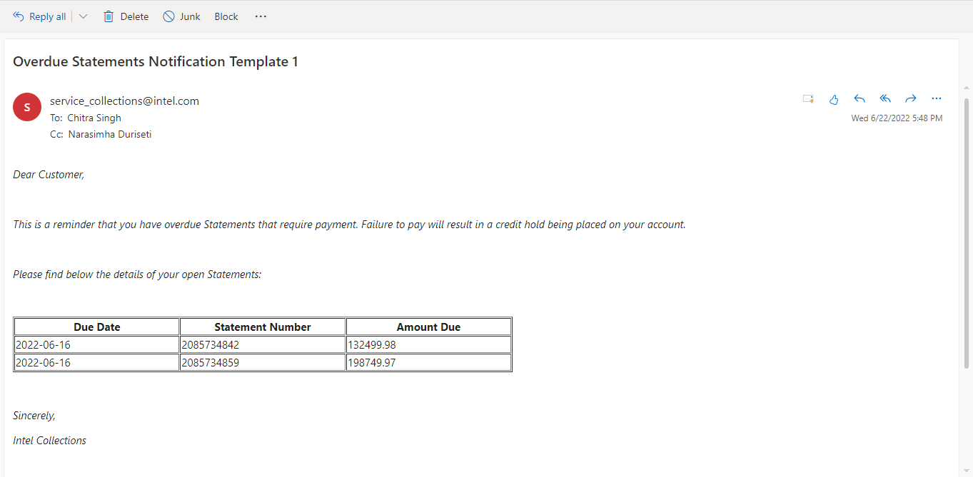

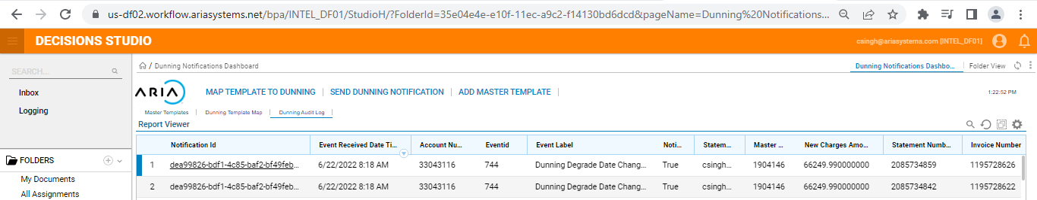

# UC 4 : As a user when an account is over due and dunning step is updated to 1 and Dunning template against dunning step 1 is deactivated , Dunning notification mail should not be sent to the customer

Steps Followed :

1. In WFINTEL instance deactivate Standard template1
2. Create an account and invoice (Parent child accounts)

* Invoice created and event 901 is generated.
* There are 3 unpaid Invoices

1. Update the dunning step to 1 in Aria

* Event 744 Dunning Degrade Date Changed will the generated
* Workflow will listen to the event
* Email notification to customers Statement contact email will not be sent

Expected Result : Dunning Email notification for the pending invoices should not be sent to the Statement contact mail id in Standard template 1 for dunning step 1

Actual Result : Dunning Email notification for the pending invoices is not sent to the Statement contact mail id in Standard template 1 for dunning step 1

Screen shots :

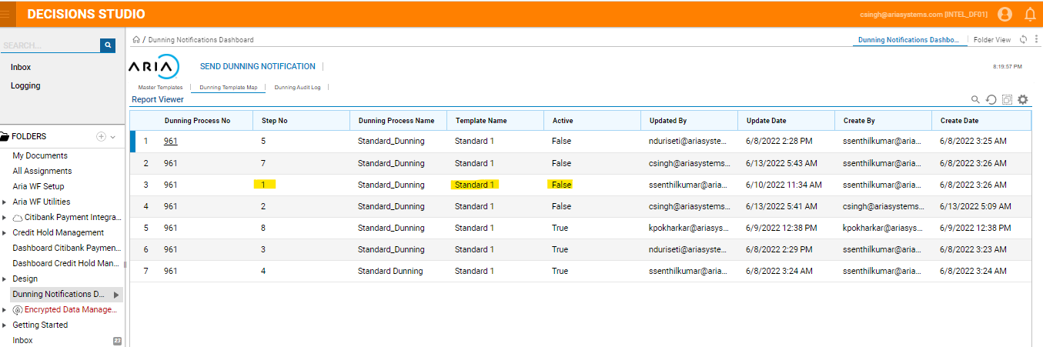

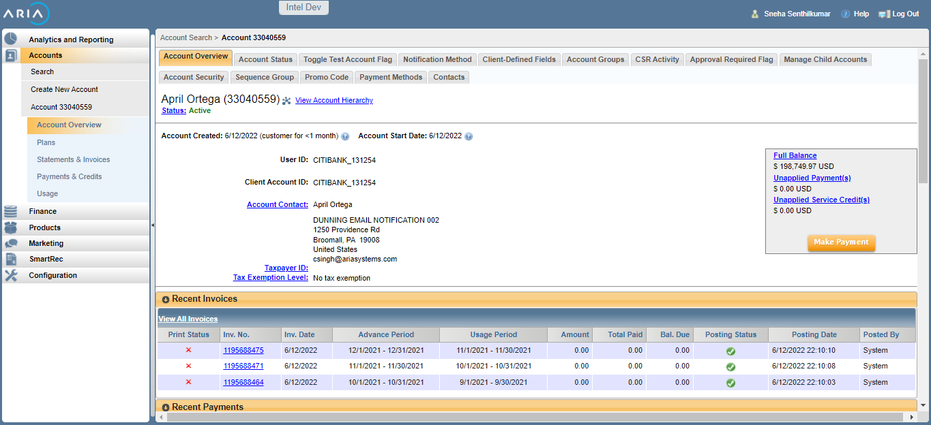

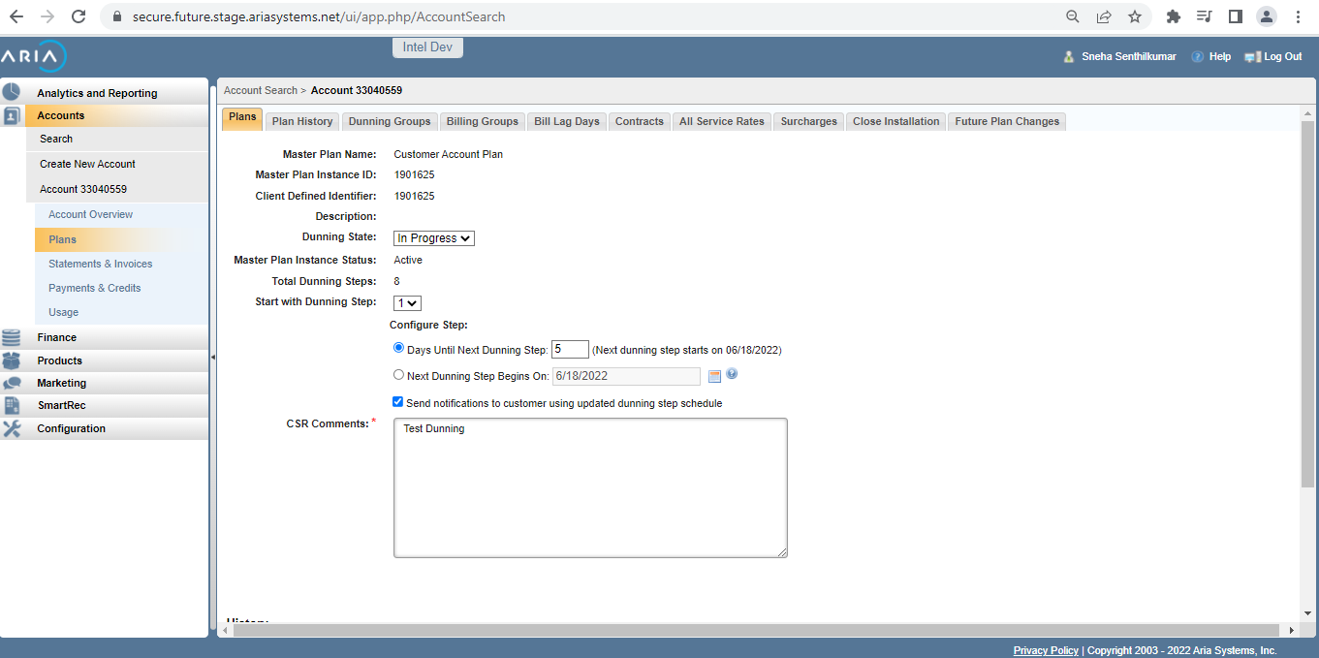

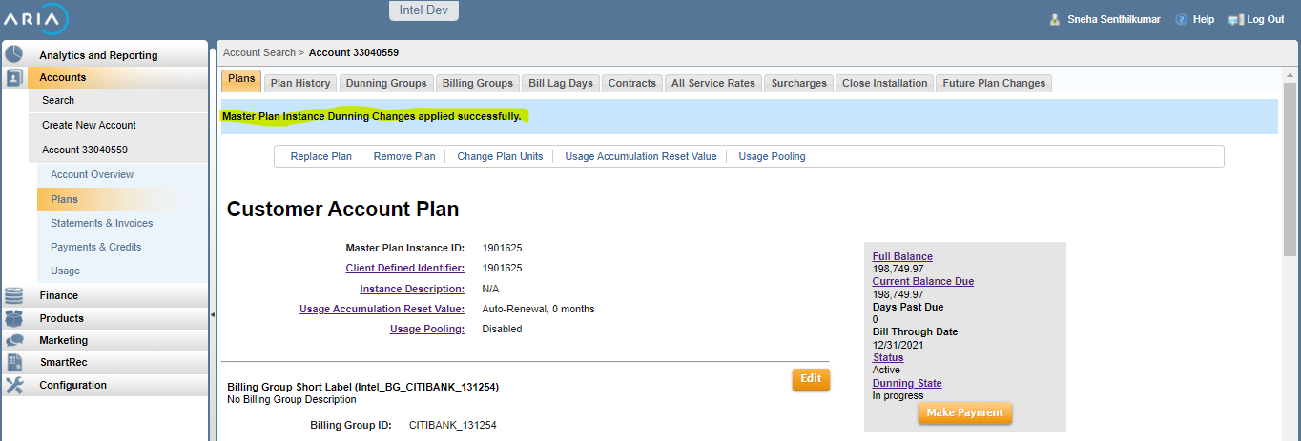

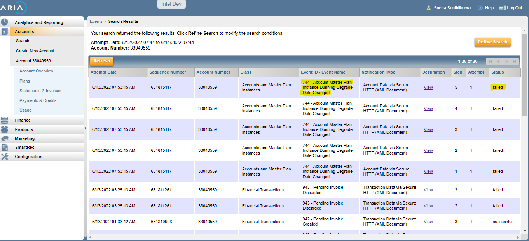

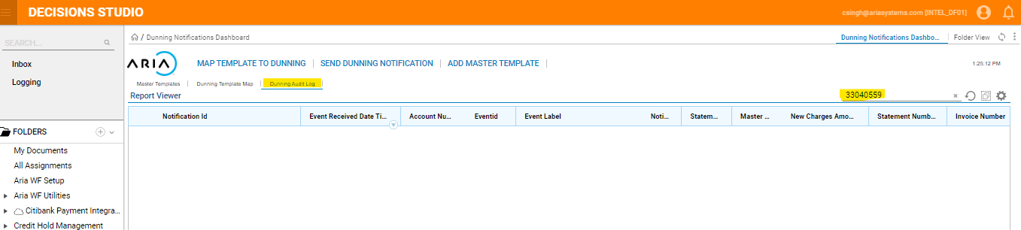

# UC-05 - As a user when my account Invoice is overdue and manual dunning is triggered , an email notification in Standard1 template with details of all open invoices with due amount should be sent to the Statement mail id

Steps followed :

1. In WFINTEL instance map the dunning step with Standard template1
2. Create an account and invoice (Parent child accounts)

* Invoice created and event 901 is generated.
* There are 3 unpaid Invoices

1. In WorkFlow , Dunning Notification

* Search for the account by entering in Account No. Field (here 33040546)
* Select the template and click on “ Notify past Due”
* Workflow will listen to the event and send an Email notification to customers Statement contact email with list of only unpaid Statements with due amount.
* Dunning notification events notated in Aria account’s comments section
* In WorkFlow Dunning audit log is updated with the Notification ID and event id as “0”

Expected Result : Dunning Email notification for the pending invoices should be sent to the Statement contact mail id .

Actual Result : Dunning Email notification only for the pending invoices is sent to the Statement contact mail id

Screen shots :

Account # 33040546

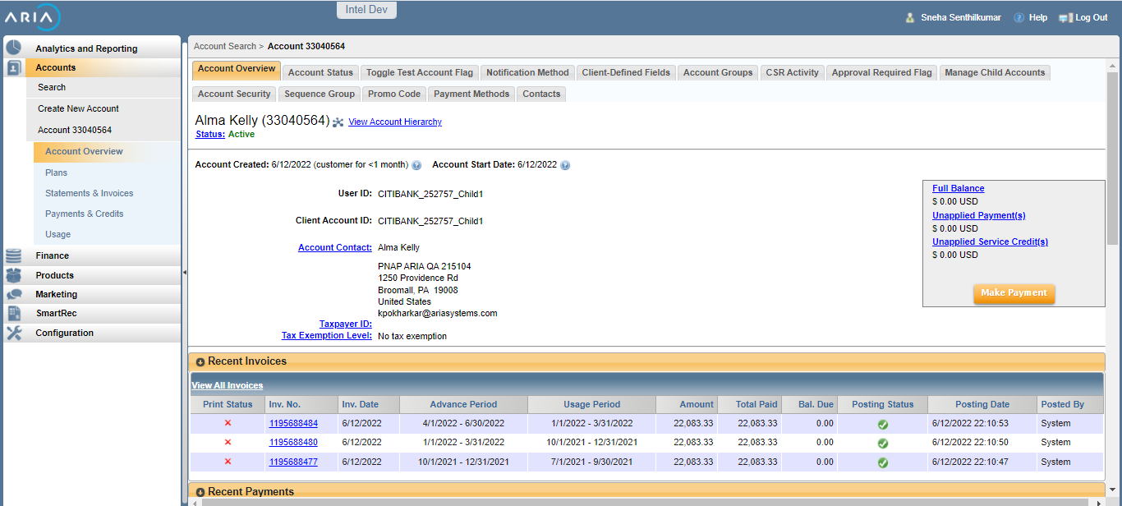

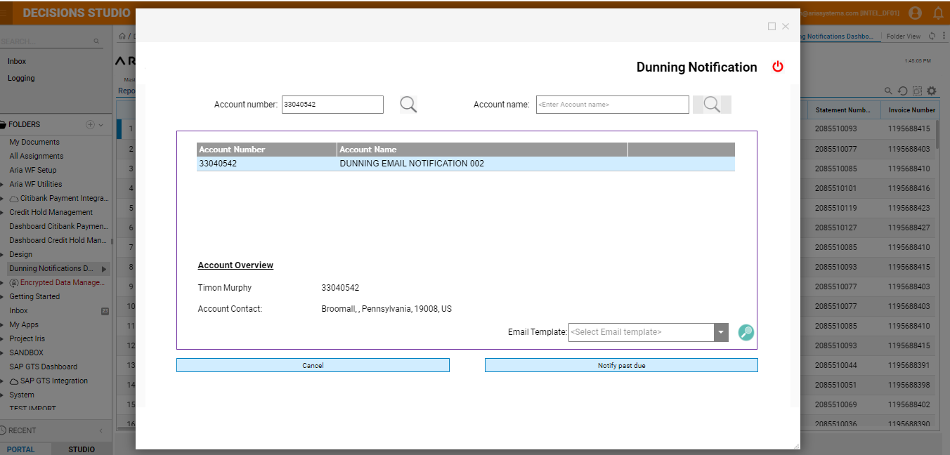

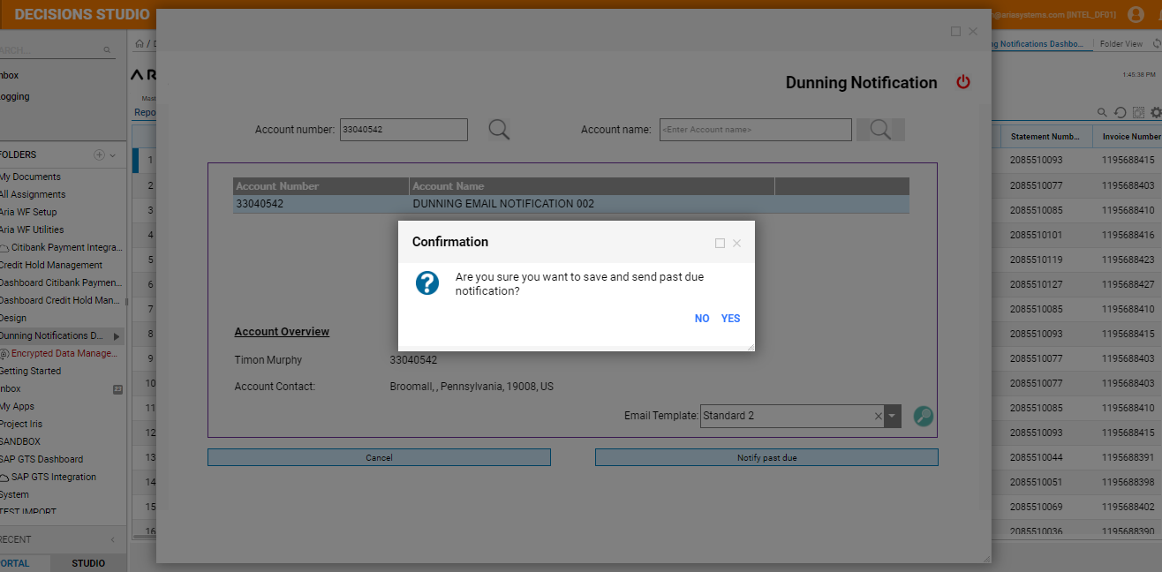

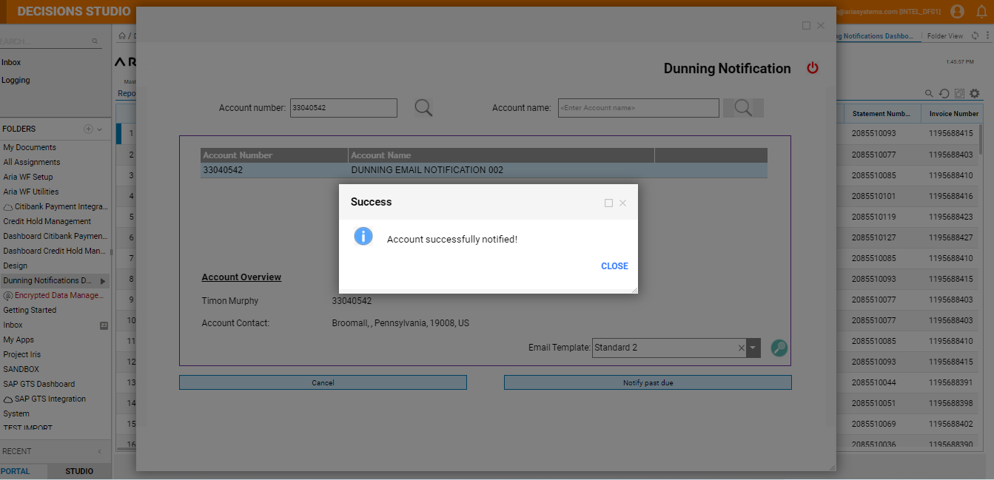

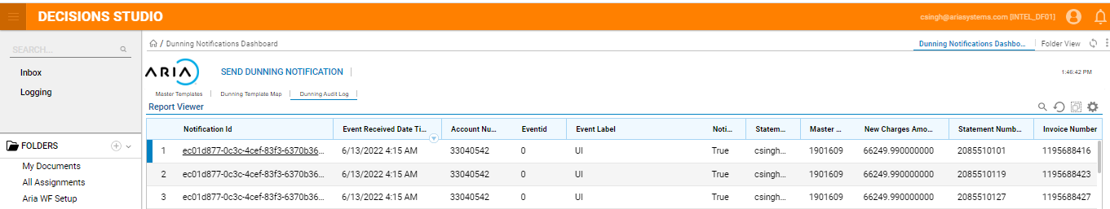

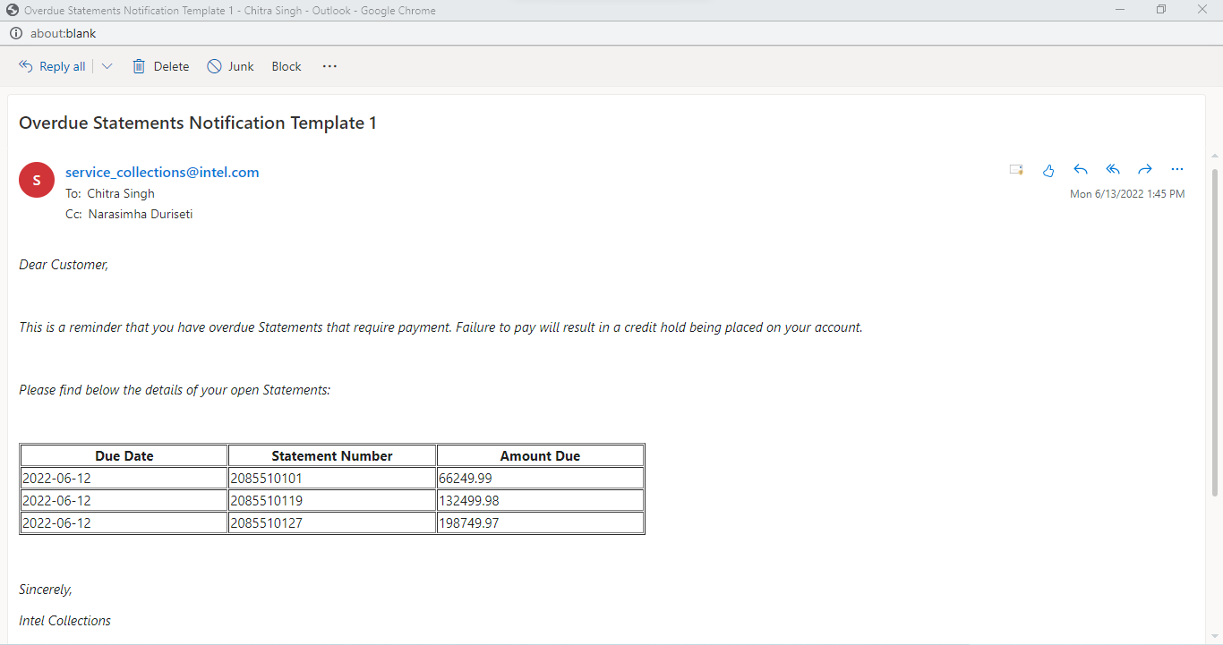

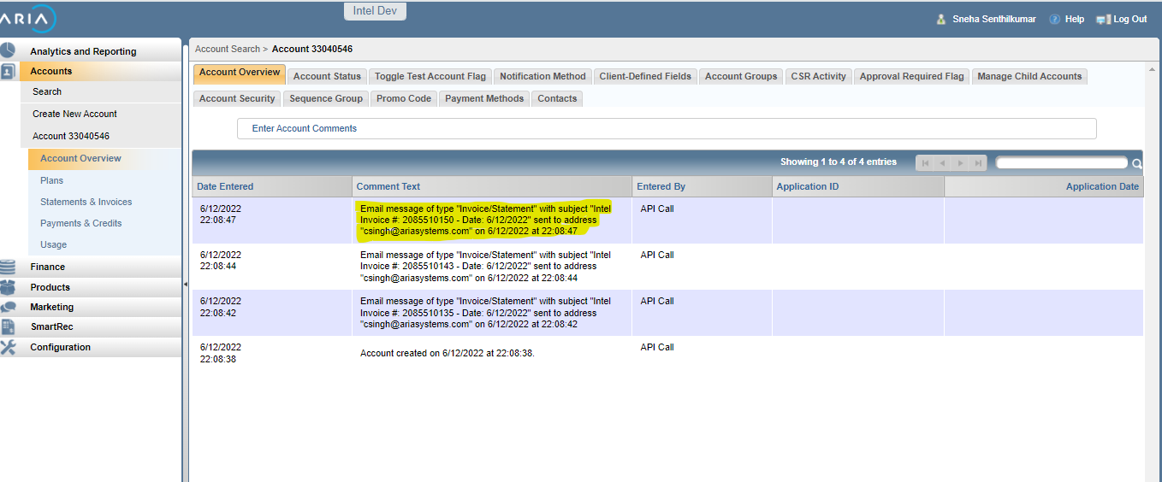

# UC_06 : As a user when my Account Invoice is overdue and manual dunning is triggered , an automatic email in Standard2 template, with details of all open invoices with due amount should be sent to the statement mail id

Steps followed :

1. In WFINTEL instance map the dunning step with Standard template1
2. Create an account and invoice (Parent child accounts)

* Invoice created and event 901 is generated.
* There are 3 unpaid Invoices

1. In WorkFlow , Dunning Notification

* Search for the account by entering name in “Account name” field.
* Select the template and click on “Notify past Due”
* Workflow will listen to the event and send an Email notification to customers Statement contact email with list of only unpaid Statements with due amount.
* Dunning notification events notated in Aria account’s comments section
* In WorkFlow Dunning audit log is updated with the Notification ID and event id as “0”

Expected Result : Dunning Email notification for the pending invoices should be sent to the Statement contact mail id .

Actual Result : Dunning Email notification only for the pending invoices is sent to the Statement contact mail id

Screen shots :

Account # 33040551

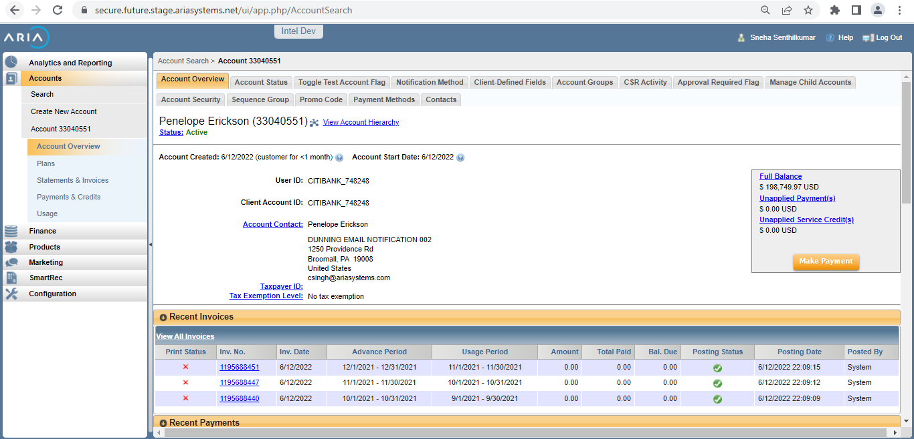

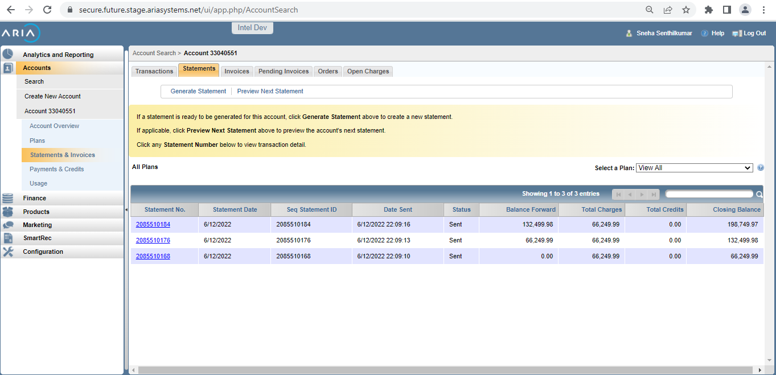

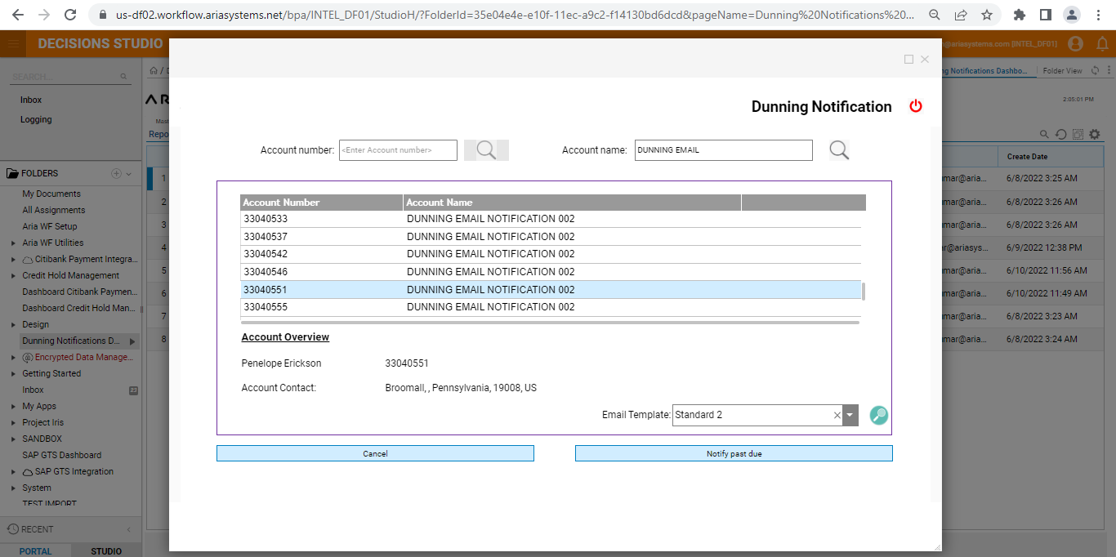

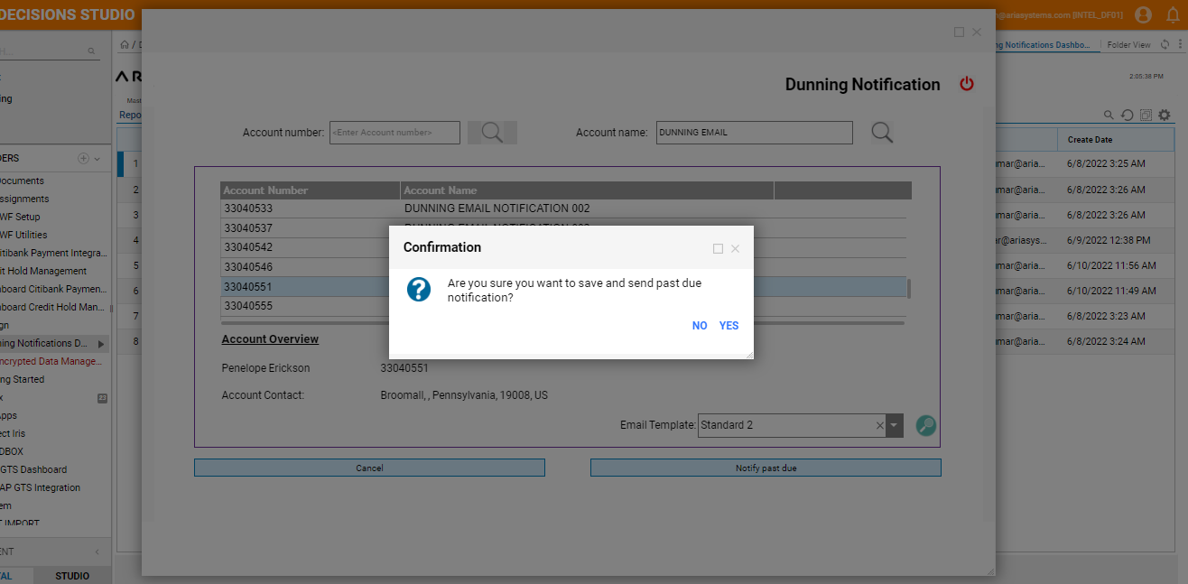

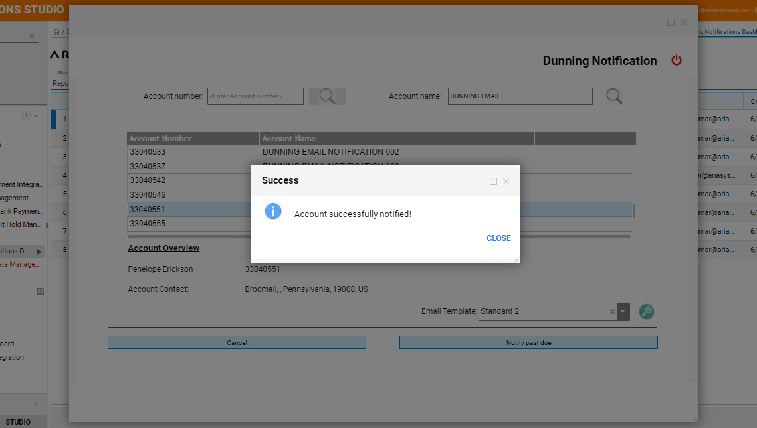

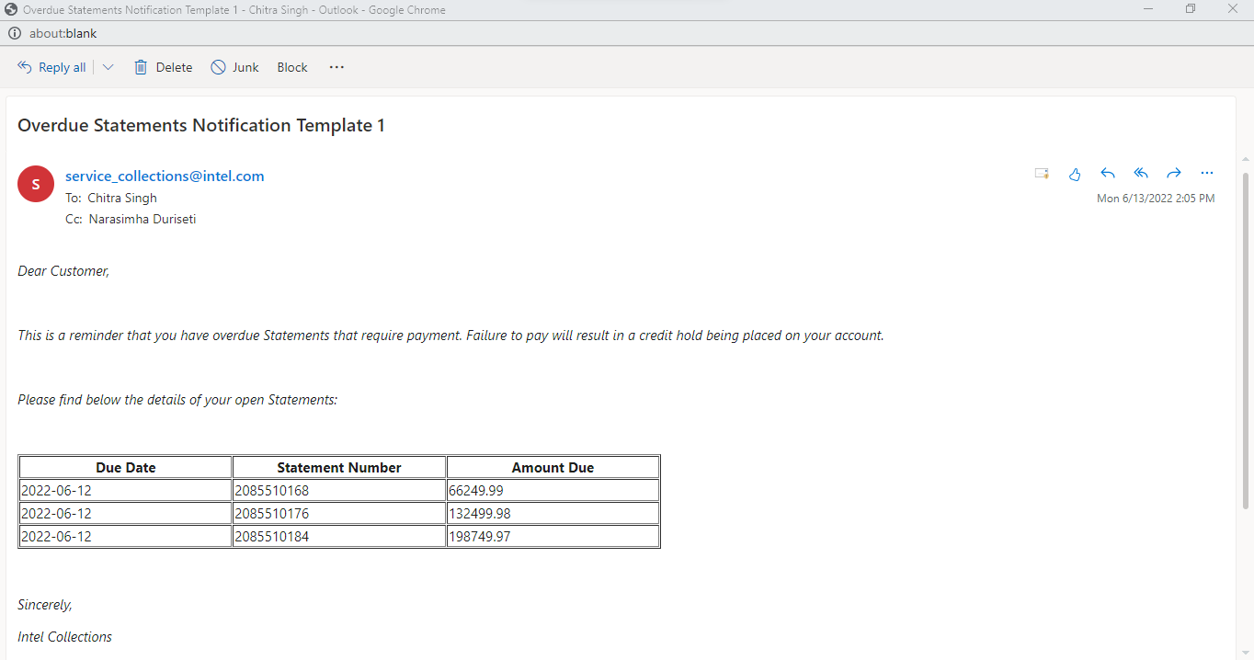

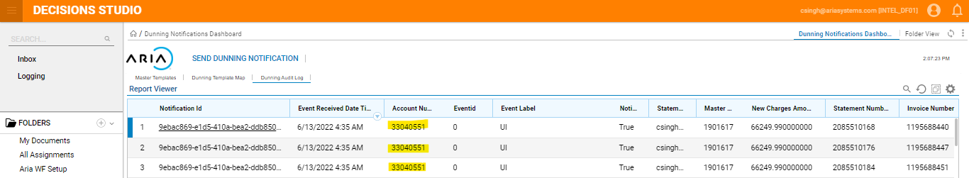

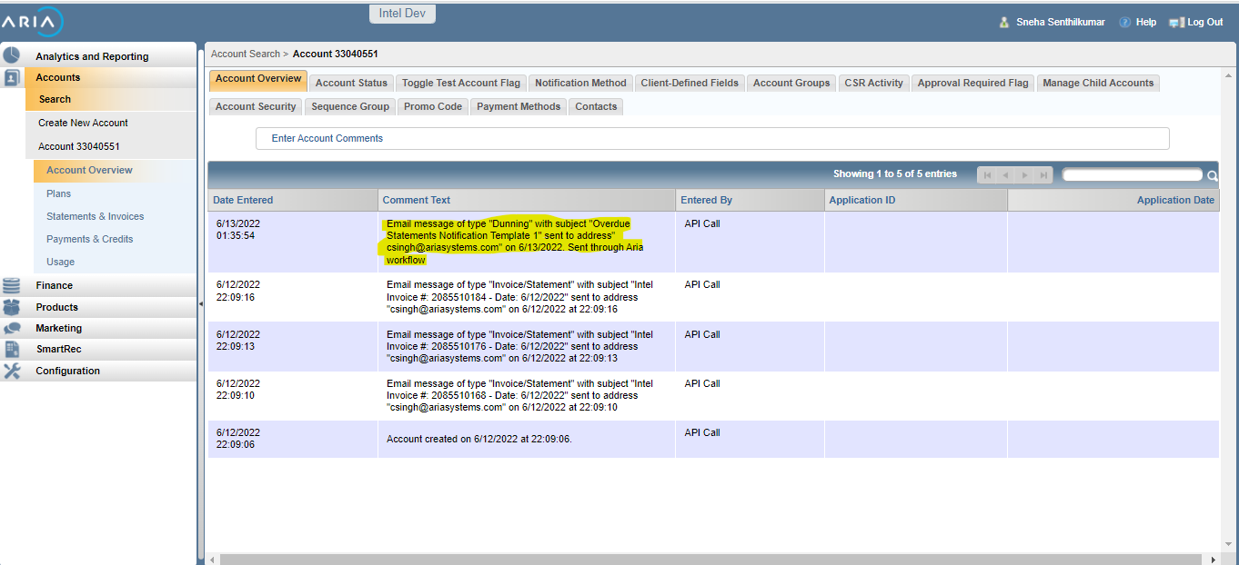

# UC-07 - As a user when payment for one the invoice is completed and 2 other invoice is overdue and manual dunning is triggered , an email notification in Standard2 template wrt only the open invoices due amount should be sent to the Statement mail id

Steps followed :

1. In WFINTEL instance map the dunning step with Standard template1
2. Create an account and invoice (Parent child accounts)

* Invoice created and event 901 is generated.
* There are 3 unpaid Invoices

1. Apply an external payment (66249.99K)

* Event 903 Check created will be generated

1. In Work Flow Dunning Notification

* Search for the account and trigger manual dunning mail
* Event 744 Dunning Degrade Date Changed will the generated
* Workflow will listen to the event and send an Email notification to customers Statement contact email with list of only unpaid Statements with due amount.
* Dunning notification events notated in Aria account’s comments section
* In WorkFlow Dunning audit log is updated with the Notification ID and event id as “0”

Expected Result : Dunning Email notification for the unpaid invoices should be sent to the Statement contact mail id .

Actual Result : Dunning Email notification only for the pending invoices is sent to the Statement contact mail id .

Account # 33040555

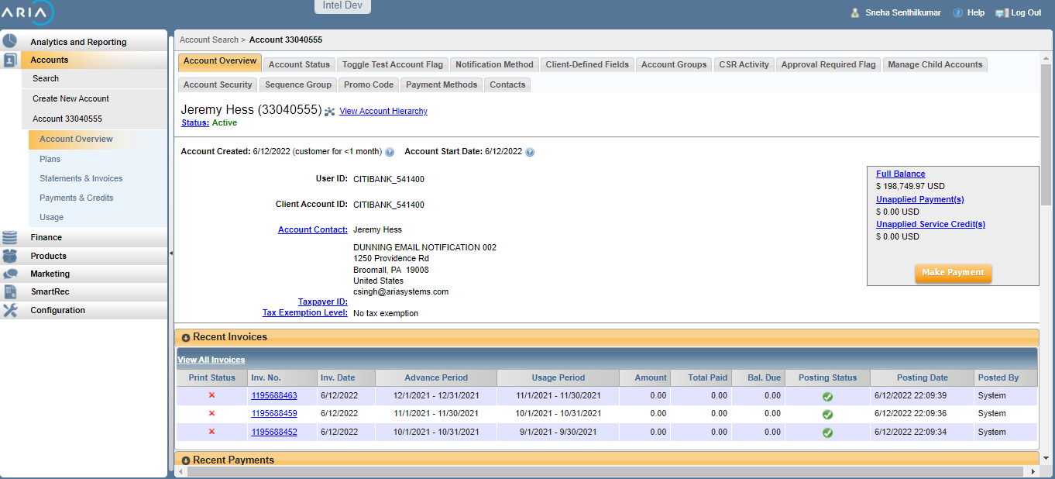

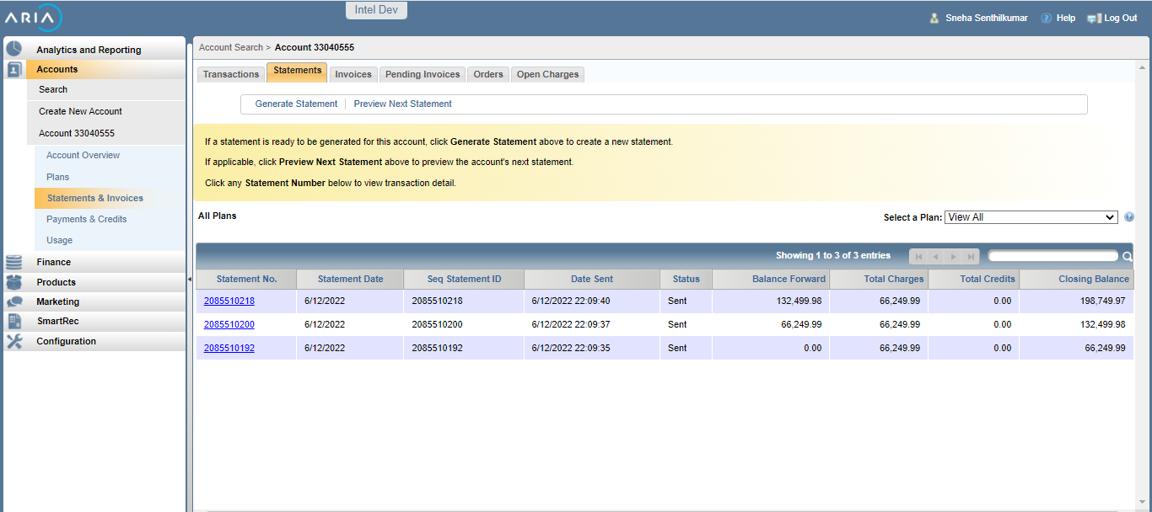

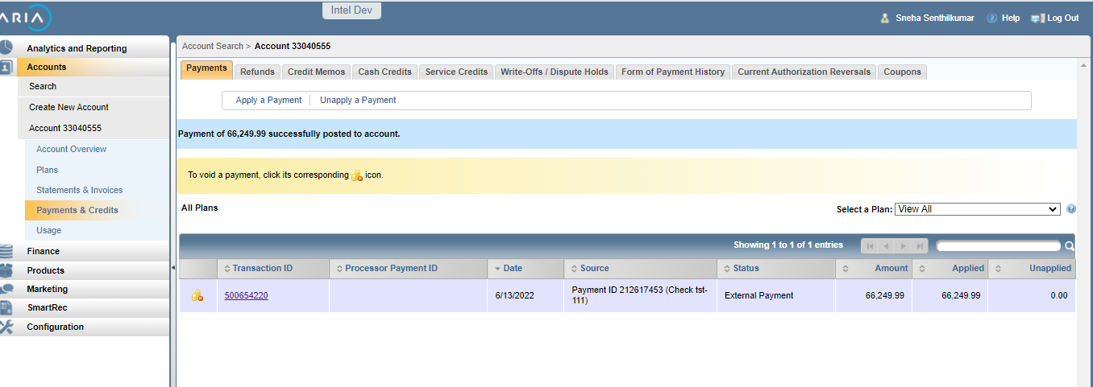

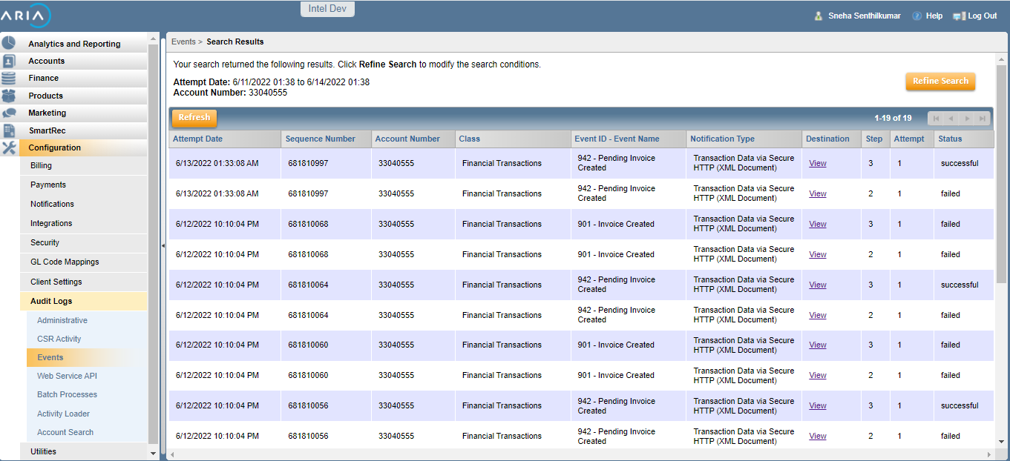

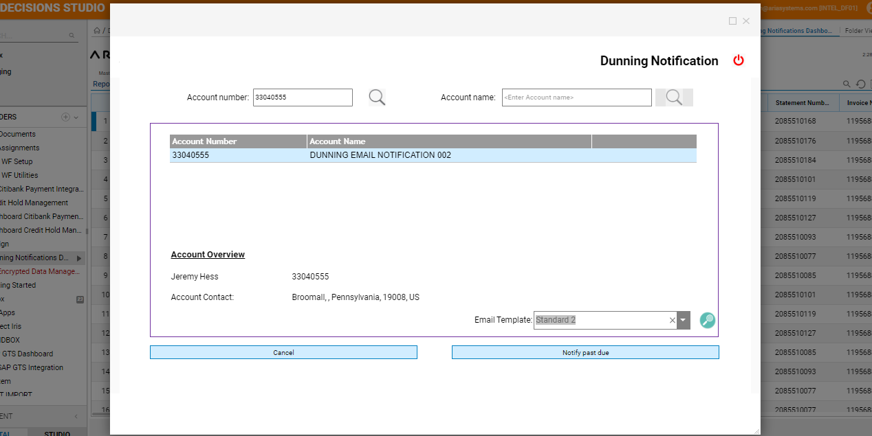

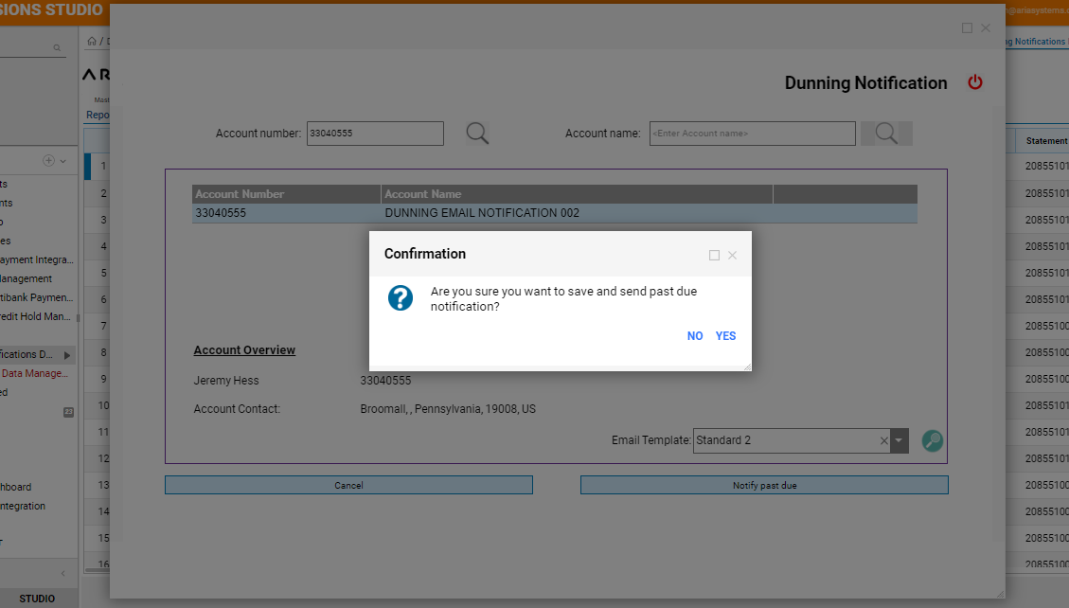

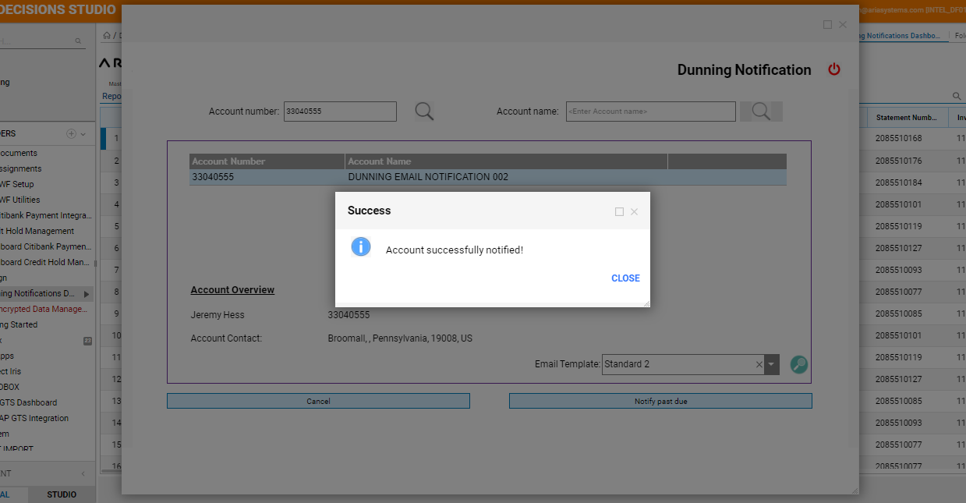

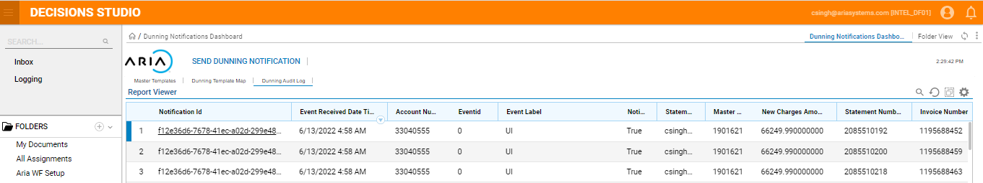

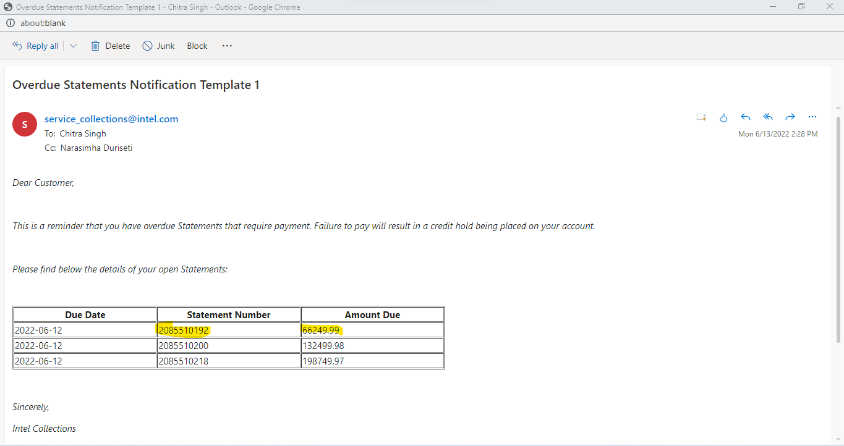

# UC -08 : As a user when my account is over due but in Workflow when I search the related child account to send the email notification , error message should be displayed.

Steps followed :

1. In WFINTEL instance map the dunning step with Standard template1
2. Create an account and invoice (Parent child accounts)

* Invoice created and event 901 is generated.
* There are 3 unpaid Invoices

1. In WorkFlow dunning notification

* Search for the child account
* Error message should be displayed

Expected result - Error message should be displayed when Child account# is searched in Dunning Notification

Actual result - Error message is displayed when Child account# is searched in Dunning Notification

Screen Shots :

Account No: 33040555

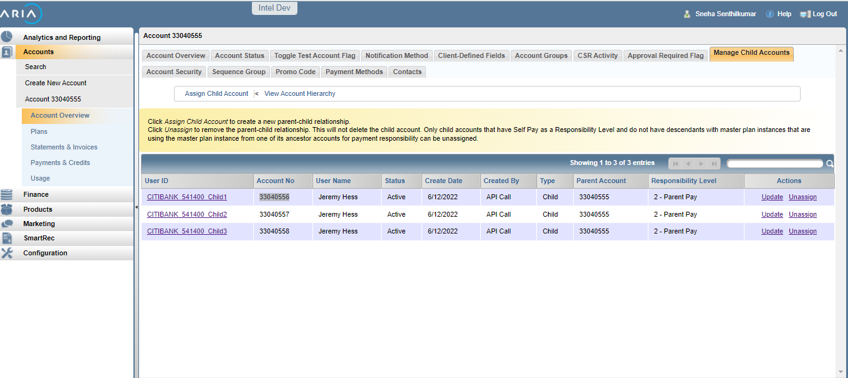

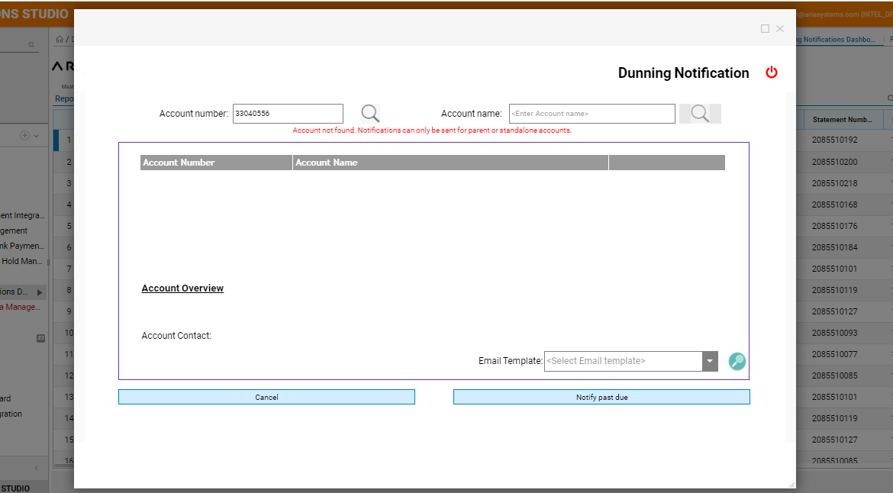

# Uc-09 : As a user, when I map a template to dunning I should be able to select the template for mapping , against a dunning step . And the new step should be saved in the Mapping list

Steps followed:

1) Work Flow Dunning Dashboard

* Select the existing dunning template
* Right click and select Update Dunning step

2) In Mapping Template to Dunning

* Select the Standard template 2 against dunning step 2 and Submit
* Template name is updated from “Standard 1” to “Standard 2”

Expected Result : Template should be updated from Standard 1 to Standard 2 , while Map template to dunning is updated.

Actual Result : Template is updated from Standard 1 to Standard 2 , while Map template to dunning is updated.

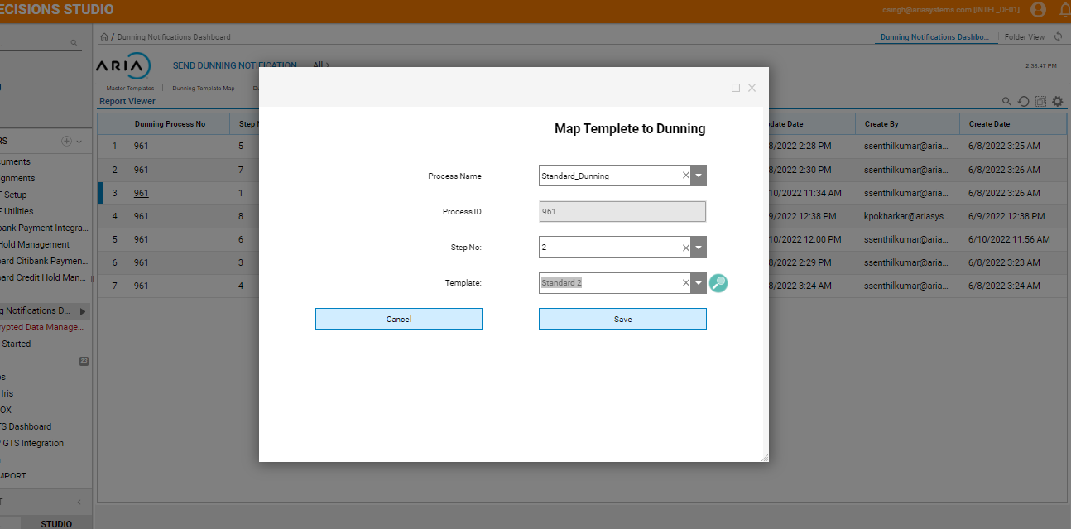

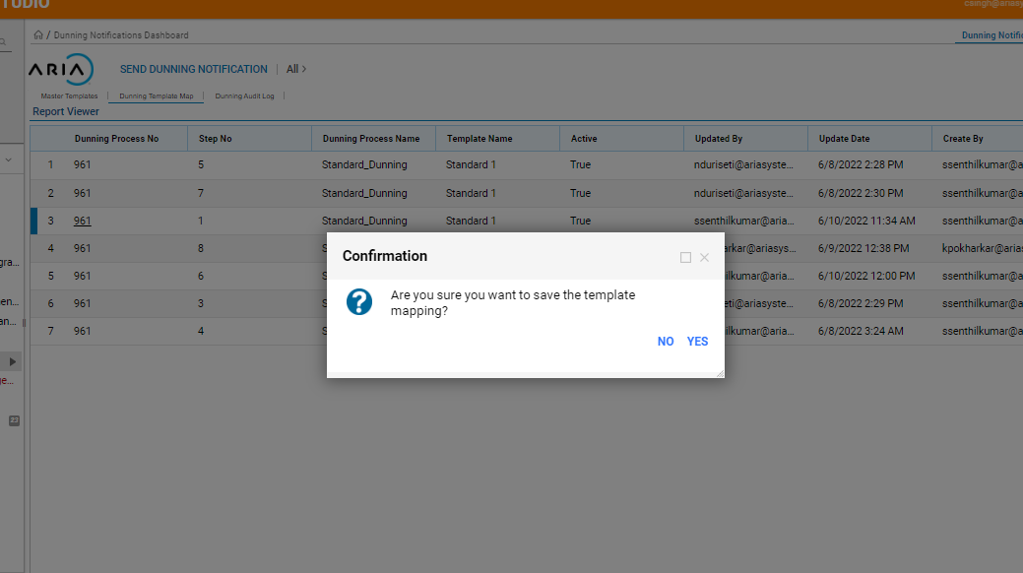

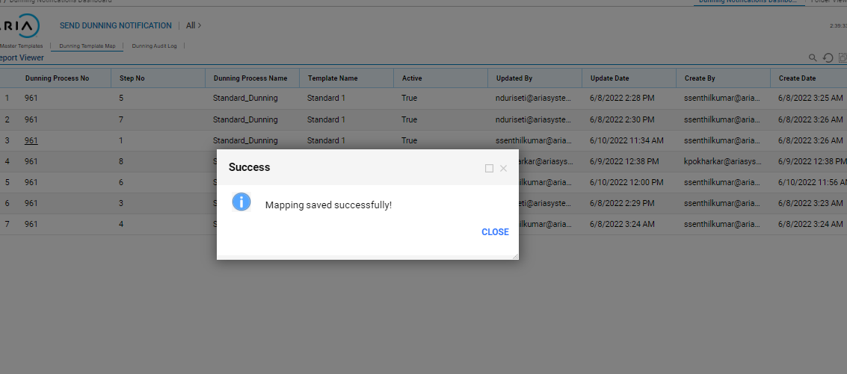

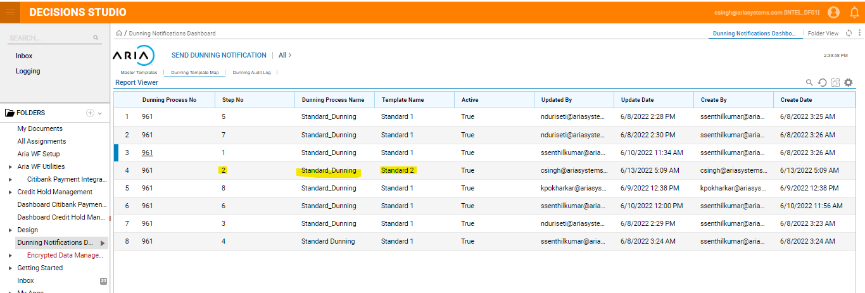

# UC-10 : As a user, when I Deactivate a dunning template - Confirmation pop up message should be displayed and Status Active flag should be updated to " FALSE"

Steps followed:

1) Work Flow Dunning Dashboard

* Select the existing dunning step
* Right click and select Deactivate dunning template
* Confirmation popup will be displayed followed by Success message
* Active Flag is updated to “False”

Expected Result : When a Dunning step is Deactivated the Active flag should be updated to False.

Actual Result : When a Dunning step is Deactivated the Active flag is updated to False.

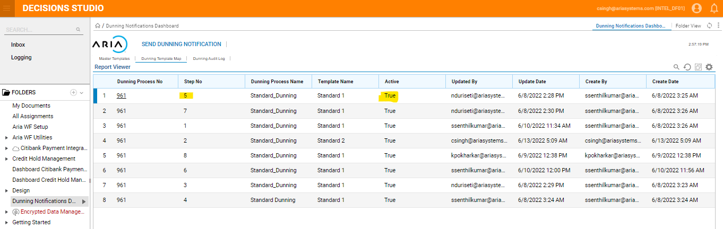

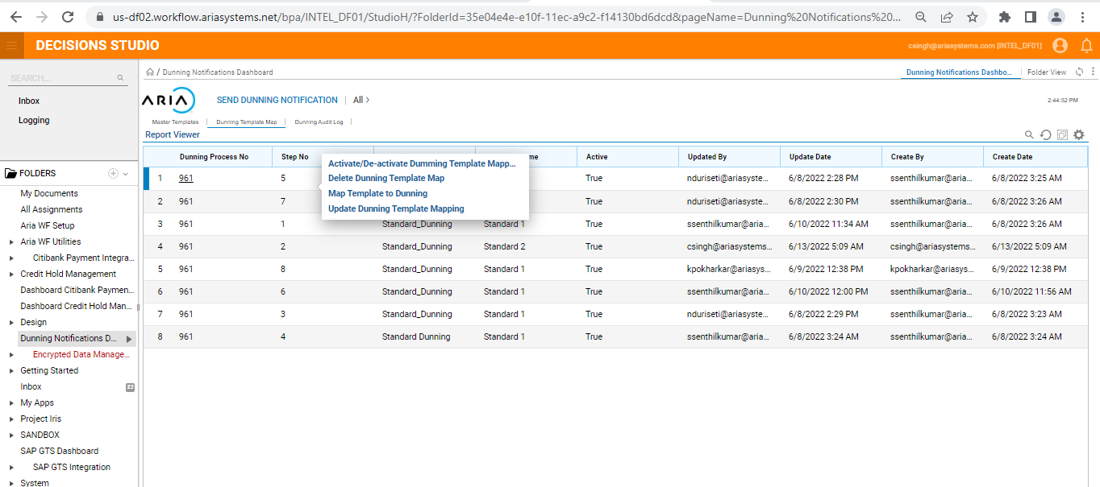

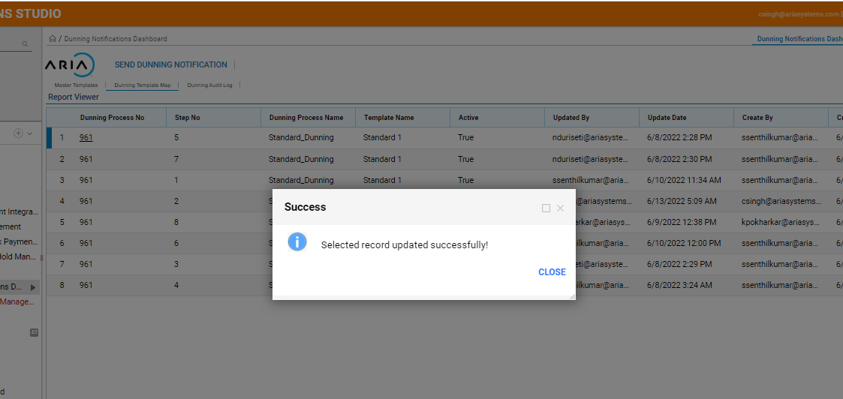

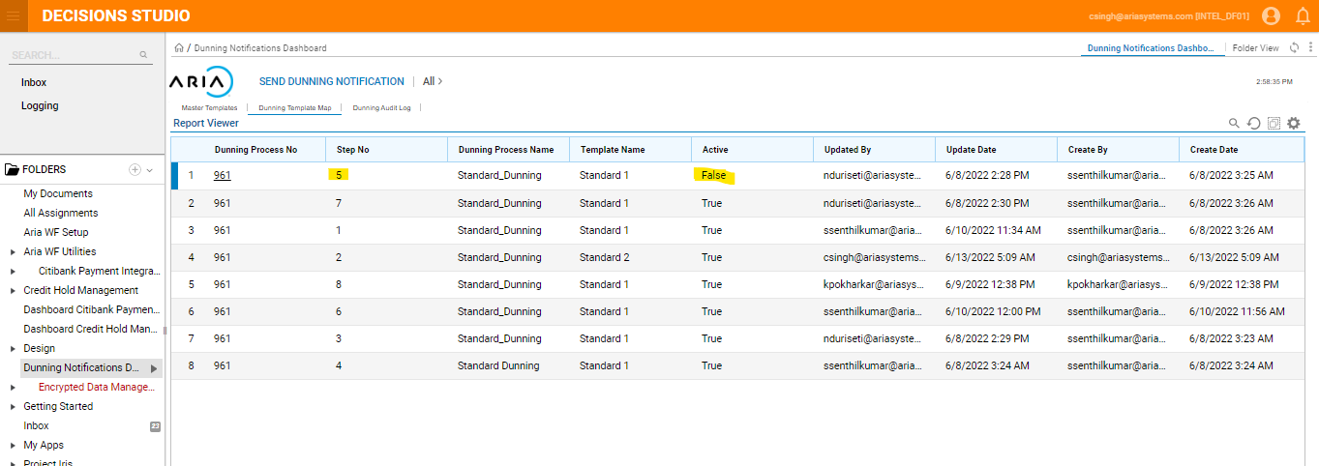

# UC-11 : As a user, when I Activate a dunning template - Confirmation pop up message should be displayed and Status Active should be updated to " TRUE"

Steps followed:

1) Work Flow Dunning Dashboard

* Select the existing dunning step with Active flag status is “False”
* Right click and select Activate dunning template
* Confirmation popup will be displayed followed by Success message
* Active Flag is updated to “True”

Expected Result : When a Dunning step is Activated the Active flag should be updated to “True”.

Actual Result : When a Dunning step is Activated the Active flag is updated to “True”.

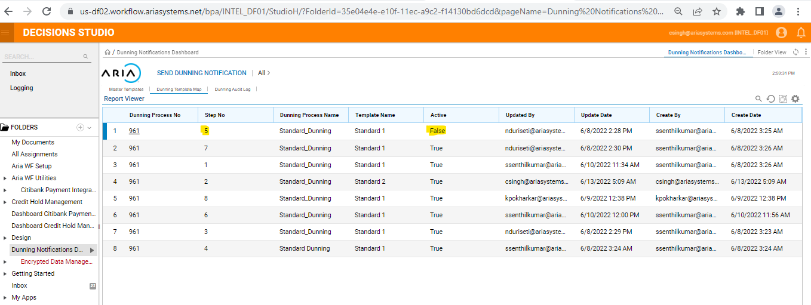

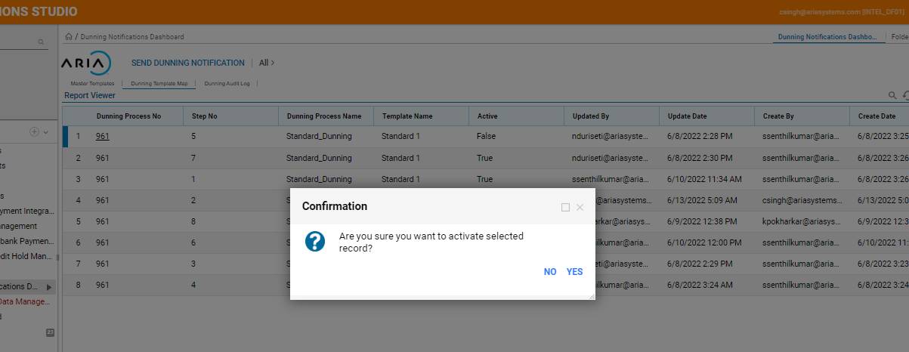

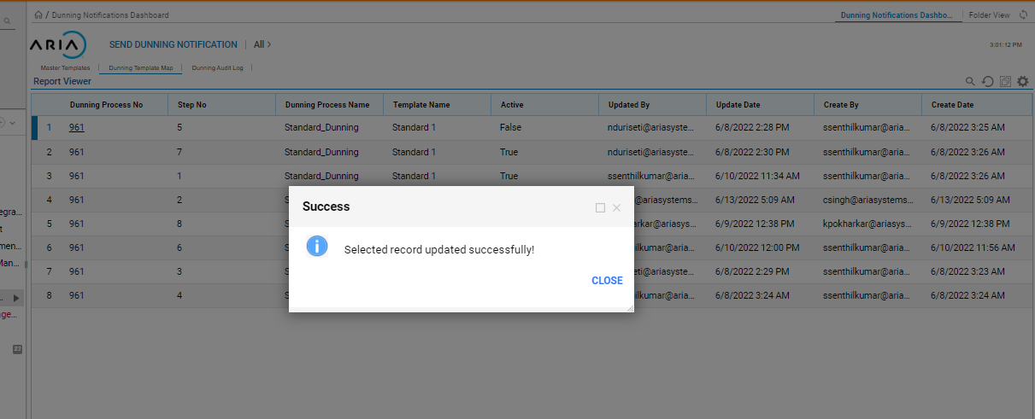

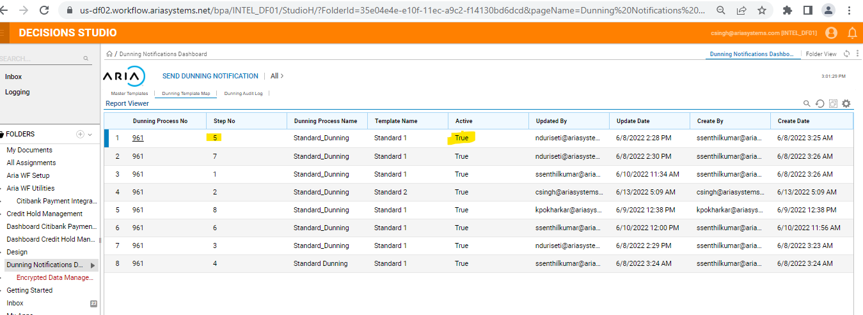

# UC-12 : As a user, when I update a dunning template of a deactivated step by selecting Active check box. Template should be updated to Standard 2 and Active flag to "True"

Steps followed:

1) Work Flow Dunning Dashboard

* Select the existing dunning step with Active flag status is “False”
* Right click and select Dunning template mapping
* Select the template and check Active check box
* Confirmation popup will be displayed followed by Success message
* Active Flag is updated to “True”

Expected Result : When a Dunning step is Updated with new dunning step Active flag should be updated to “True”.

Actual Result : When a Dunning step is Updated with new dunning step Active flag is updated to “True”.

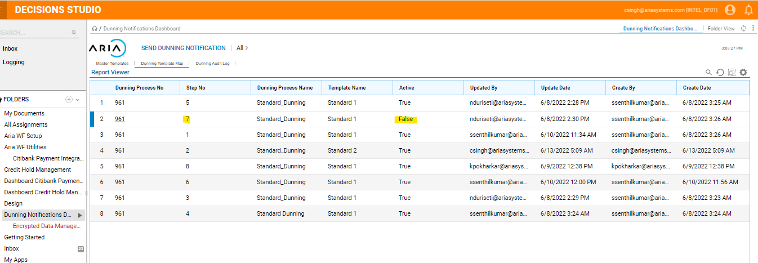

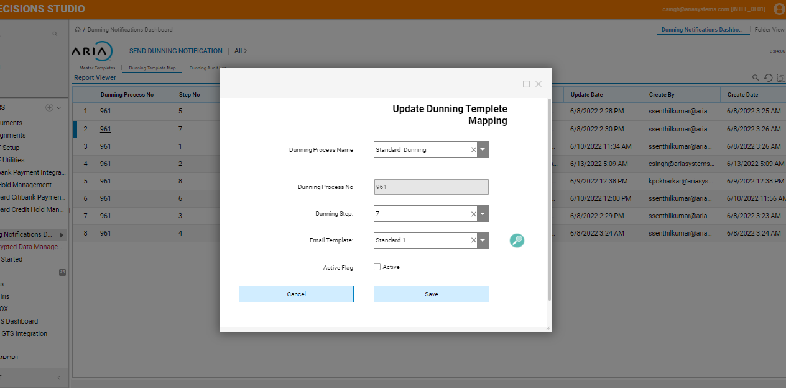

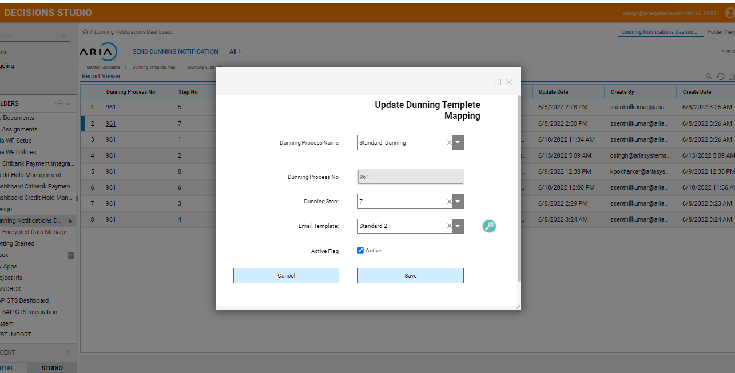

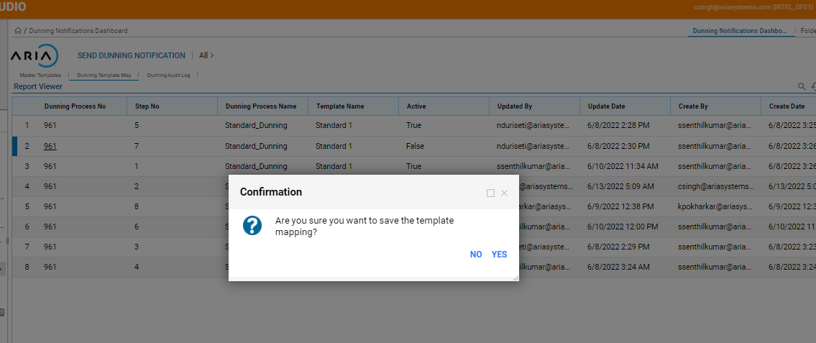

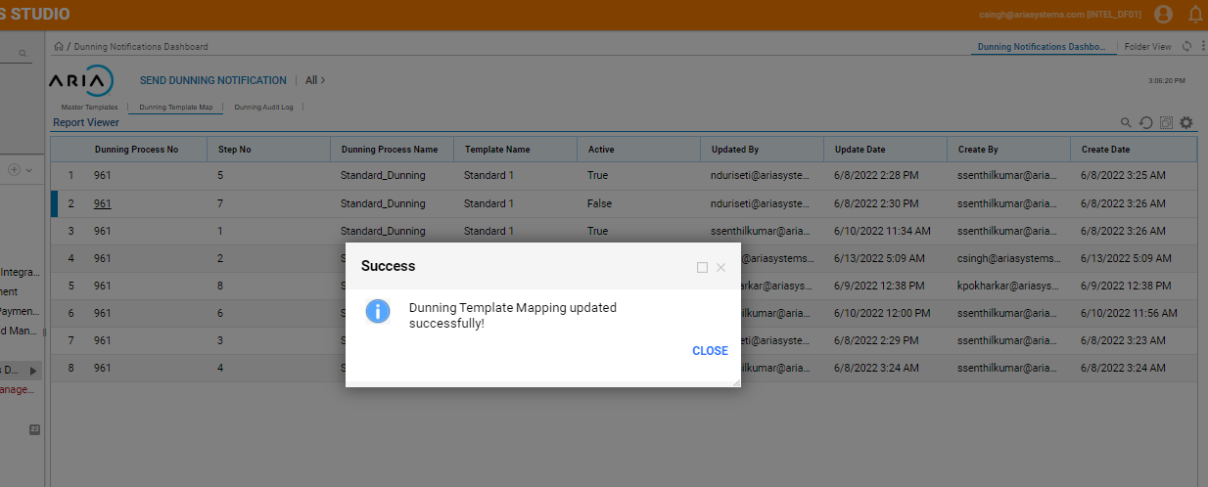

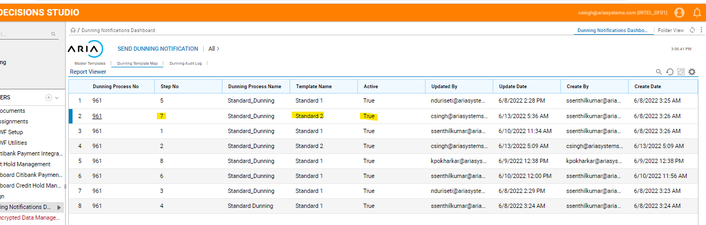

# UC-13 : As a user when I delete an existing dunning template , it should be deleted from the list

Steps followed:

1) Work Flow Dunning Dashboard

* Select the existing dunning step
* Right click and select Delete dunning template map
* Confirmation popup will be displayed followed by Success message
* Dunning step is deleted from the Dunning list

Expected Result : When a Dunning step is Deleted , it should be removed from the list.

Actual Result : When a Dunning step is Deleted , it is removed from the list.

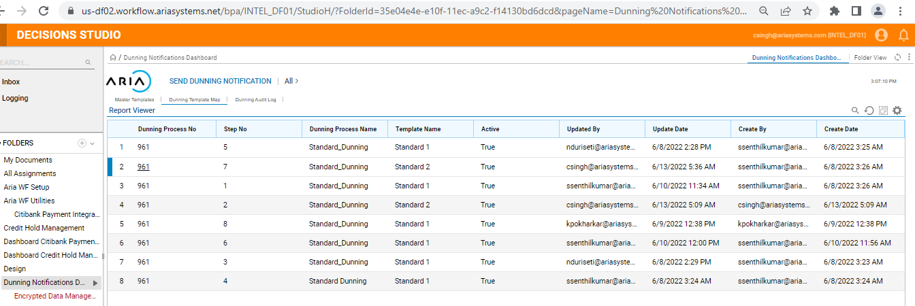

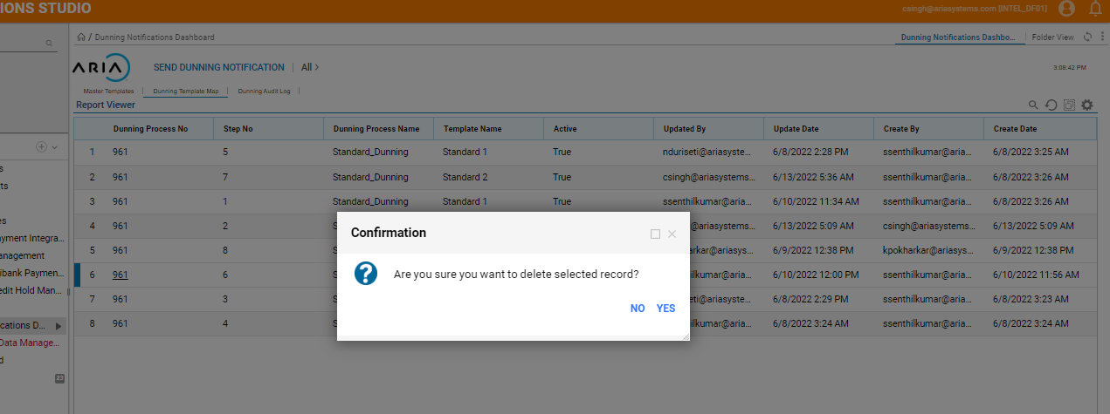

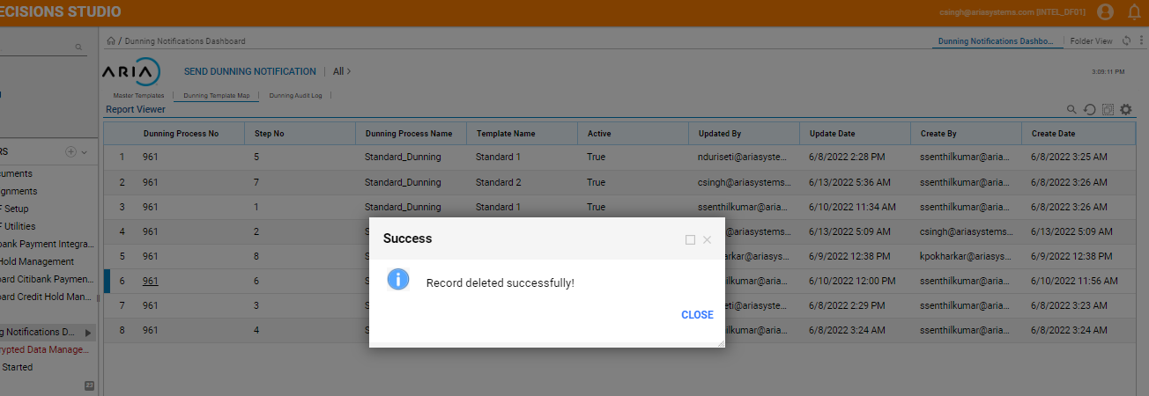

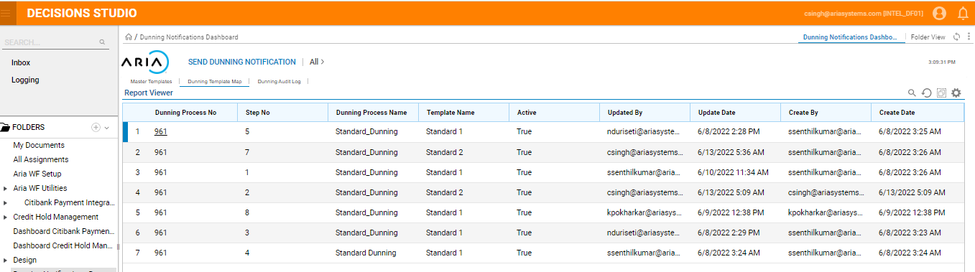

# UC-14 : As as user when I deactivate a Master template Standard 1, the active flag should be changed to "False"

Steps followed:

1) Work Flow Dunning Dashboard

* Select the existing Master template
* Right click and select De-activate dunning template
* Confirmation popup will be displayed followed by Success message
* Active Flag is updated to “Flase”

Expected Result : When a Master template De-activated the Active flag should be updated to “False”.

Actual Result : When a Master template De-activated the Active flag is updated to “False”.

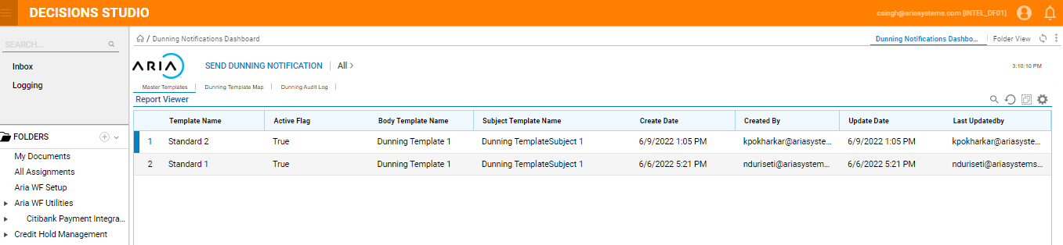

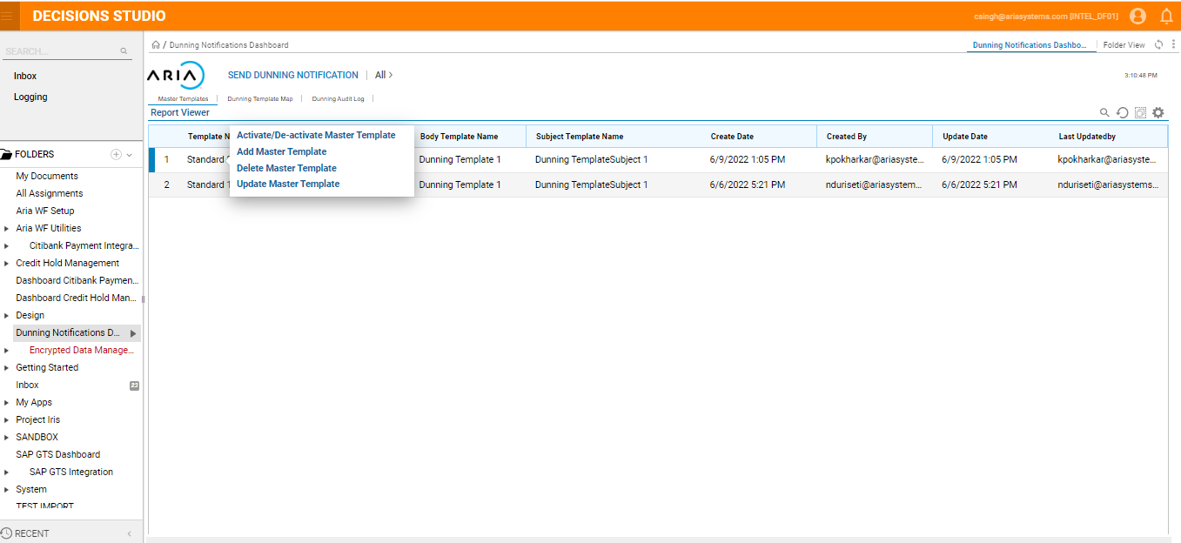

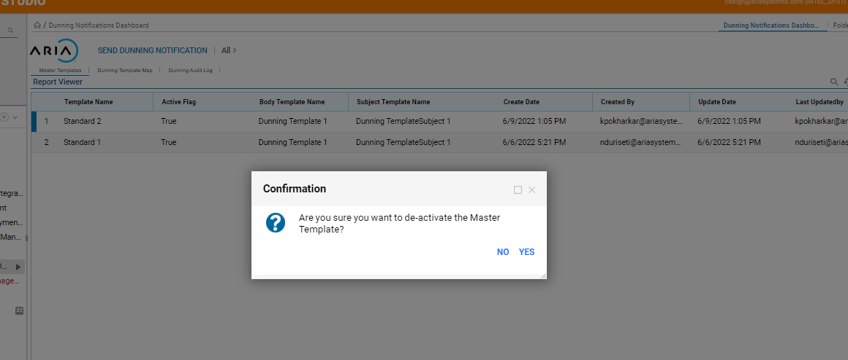

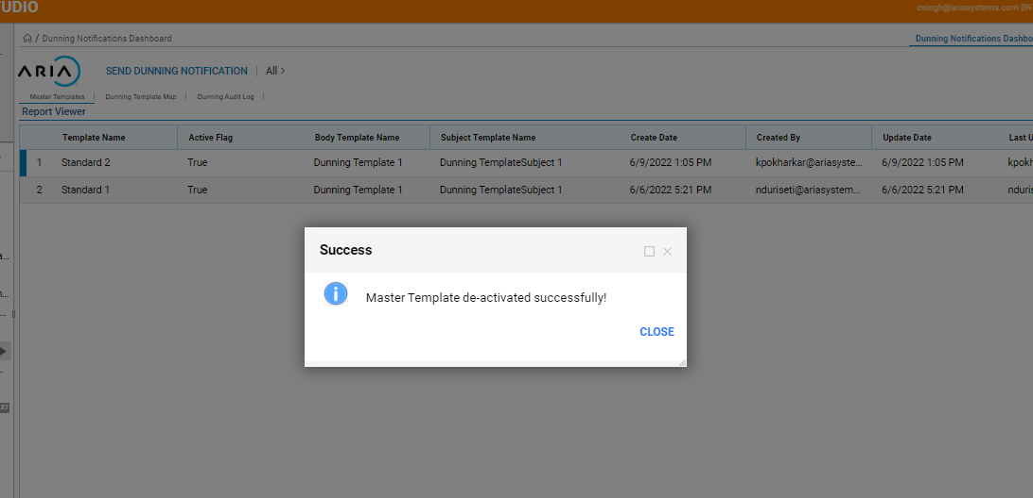

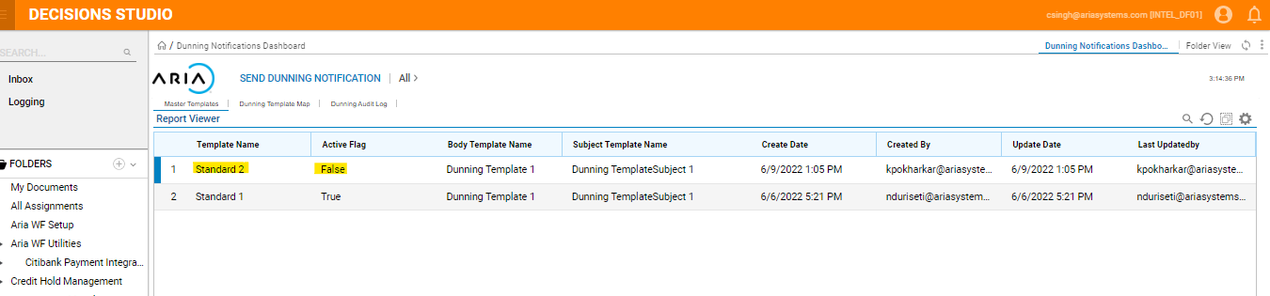

# UC-15 : As as user when I deactivate a Master template Standard 1 and the Standard Template 1 is already in use , warning message should be displayed and template should not be deactivated

Steps followed:

1) Work Flow Dunning Dashboard

* Select the existing Master template with Active status as “True”
* Right click and select De-activate dunning template
* Error message will be displayed “Selected Master template is in use, cannot be deactivated”

Expected Result: When a Master template which is already in use is De-Activated Error message should be displayed

Actual Result: When a Master template which is already in use is De-activated Error message should be displayed

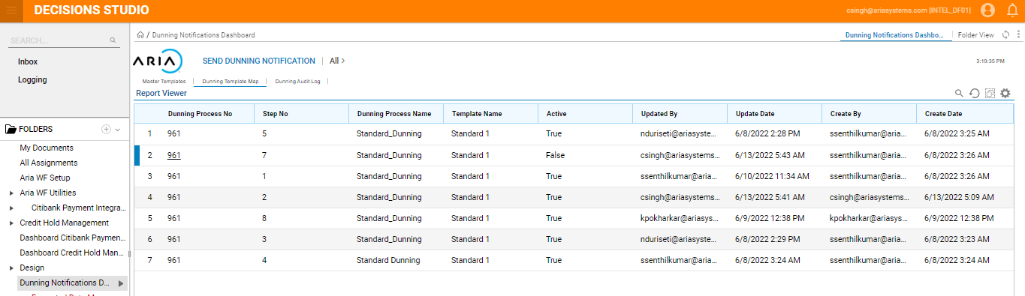

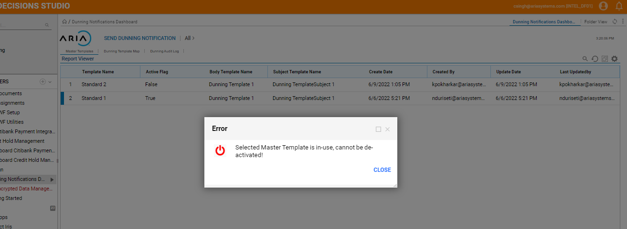

# UC-16 : As as user when I update the Dunning template mapping for a dunning step from Standard 1 to Standard 2(which is deactivated ) , only the active master template should be displayed

Steps followed:

1. Work Flow Dunning Dashboard – Master template

* Deactivate Standard template 2

1. Work Flow – Dunning template Map

* Map dunning step 5 to Standard 1 template
* Right click on dunning step 5 and select Update dunning template

1. In Update dunning template window , Standard 2 Master template should not be displayed

Expected Result: Deactivated Standard template should not be displayed when Updating the Dunning template mapping

Actual Result: Deactivated Standard template is not be displayed when Updating the Dunning template mapping

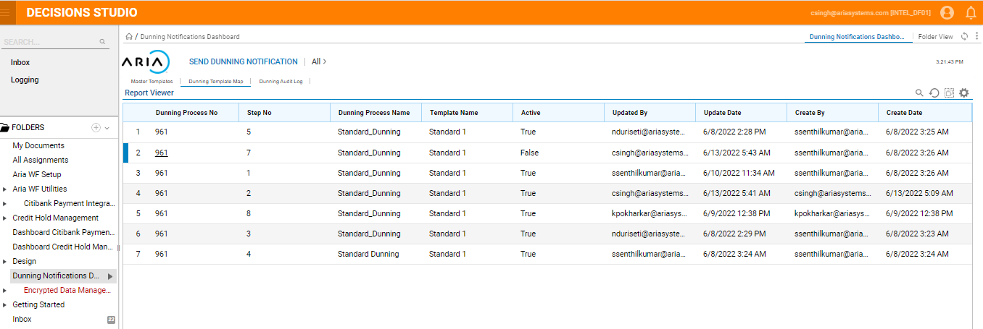

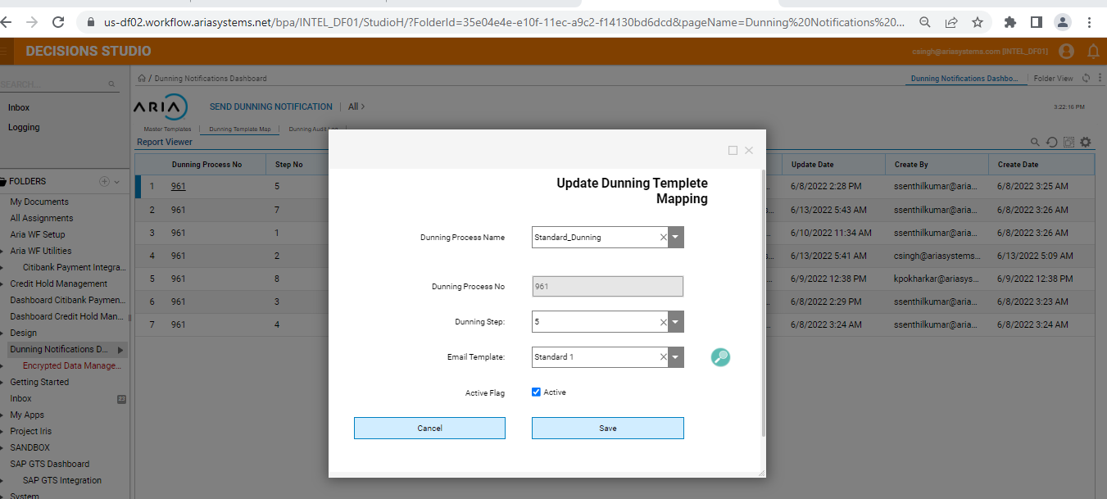

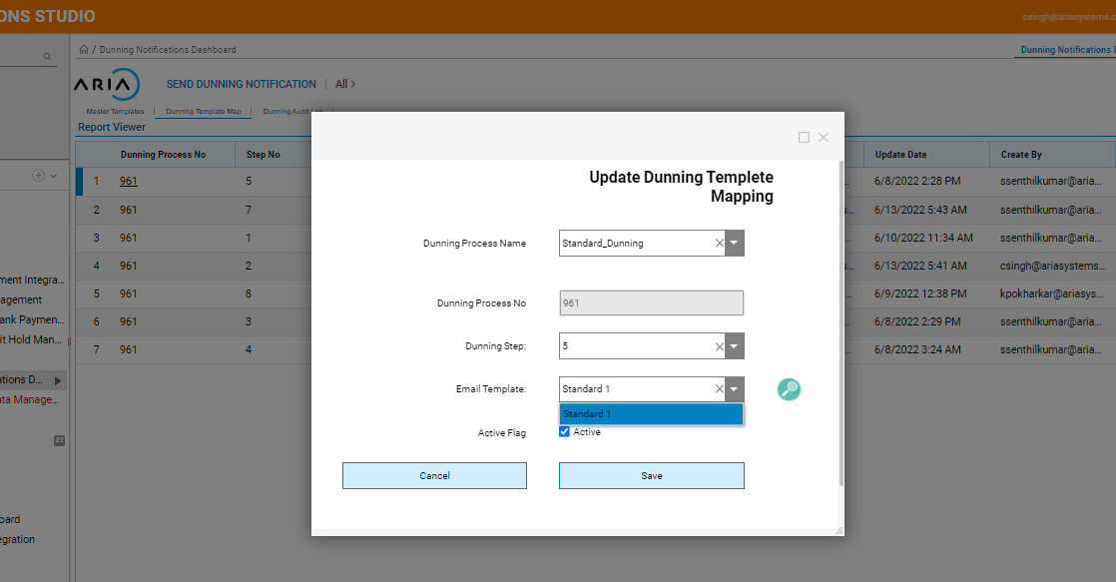

# UC-17 : As a user when I delete an existing template , it should be deleted from the Mater template list

Steps followed:

1) Work Flow Dunning Dashboard

* Select the existing Master template
* Right click and select Delete Master template
* Confirmation popup will be displayed followed by Success message
* Master template is deleted from the Master template list

Expected Result : When a Master template is Deleted , it should be removed from the list.

Actual Result : When a Master template is Deleted , it is removed from the list.

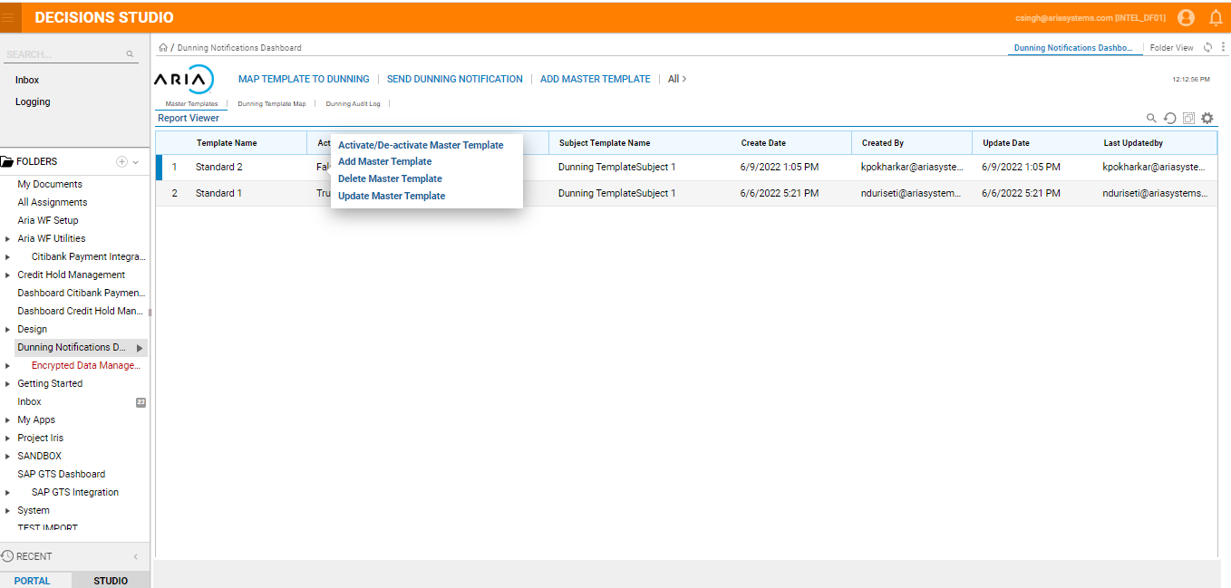

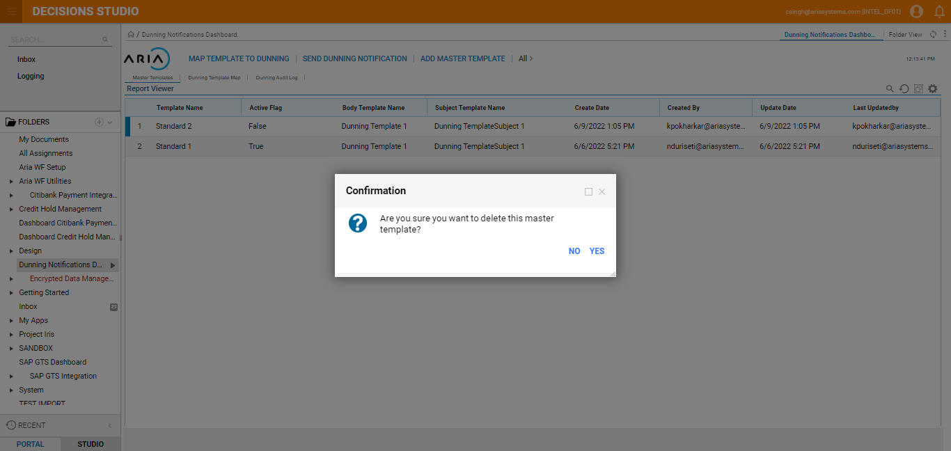

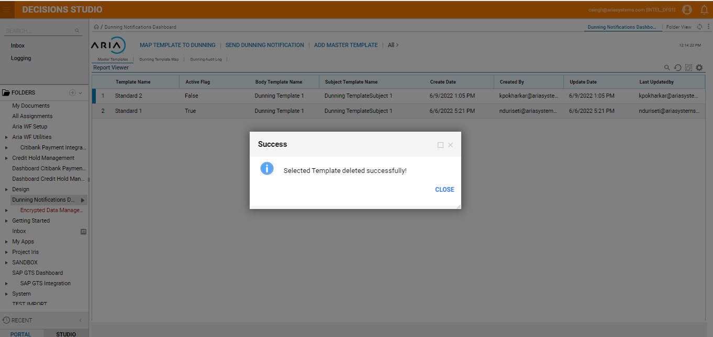

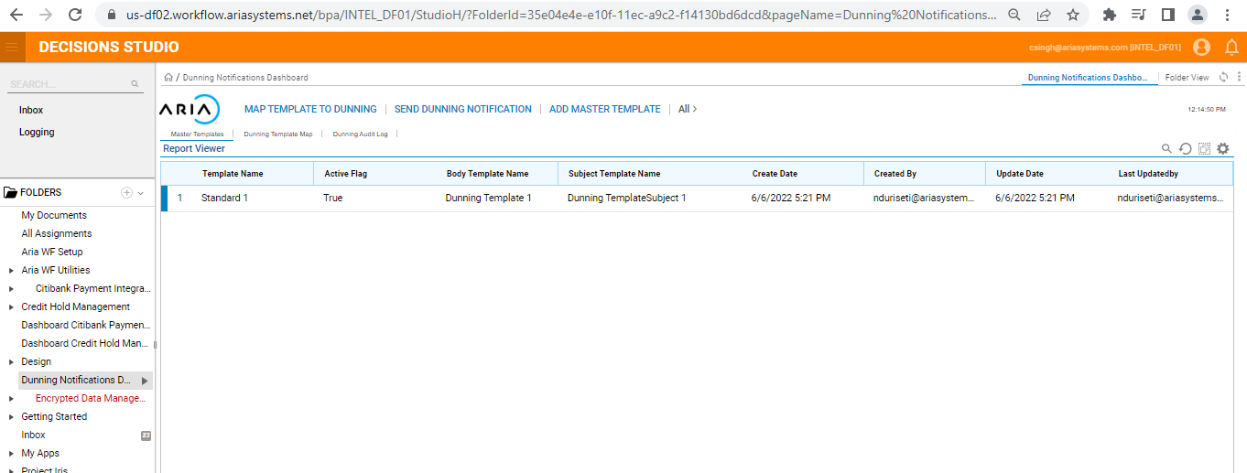

# UC-18 : As a user when Manual dunning notification is applied , I should be able to fetch the account through Account no.

Steps Followed:

1. In WFINTEL instance map the dunning step with Standard template1
2. Create an account and invoice (Parent child accounts)

* Invoice created and event 901 is generated.
* There are 3 unpaid Invoices

1. In WorkFlow, Dunning Notification

* Search for the account by entering in Account No. Field (here 33040546)
* Account no. will be displayed

Expected Result : When manual dunning notification is triggered , user should be able to search the account no. using Account number field

Actual Result : When manual dunning notification is triggered , user is able to search the account no. using Account number field

Screenshots :



# UC-19 : As a user when Manual dunning notification is applied , I should be able to fetch the account through Account name

Steps Followed:

1. In WFINTEL instance map the dunning step with Standard template1
2. Create an account and invoice (Parent child accounts)

* Invoice created and event 901 is generated.
* There are 3 unpaid Invoices

1. In WorkFlow, Dunning Notification

* Search for the account by entering in Account Name
* List of Account no. will be displayed

Expected Result : When manual dunning notification is triggered , user should be able to search the account no. using Account name

Actual Result : When manual dunning notification is triggered , user is able to search the account no. using Account number name

Screen shot :



# UC-20 : As a user when Manual dunning notification is applied , I should be preview the email template that is selected.

Steps Followed:

1. In WFINTEL instance map the dunning step with Standard template1
2. Create an account and invoice (Parent child accounts)

* Invoice created and event 901 is generated.
* There are 3 unpaid Invoices

1. In WorkFlow, Dunning Notification

* Search for the account by entering in Account No. Field (here 33040555)
* Account no. will be displayed

1. Select the Email template from the dropdown

* Click on the icon
* Email Template selected will be displayed

Expected Result : When manual dunning notification is triggered , user should be able to view the template selected

Actual Result : When manual dunning notification is triggered , user is able to view the template selected

Screenshots :

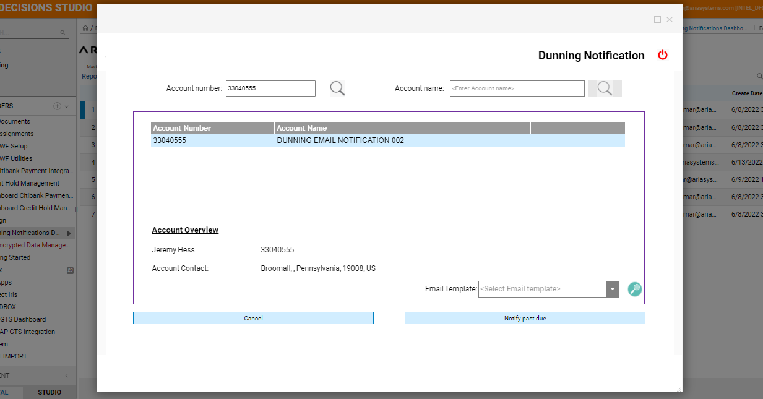

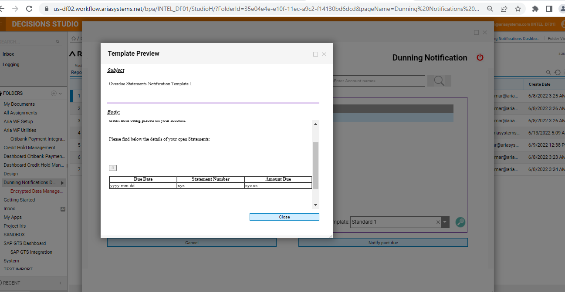

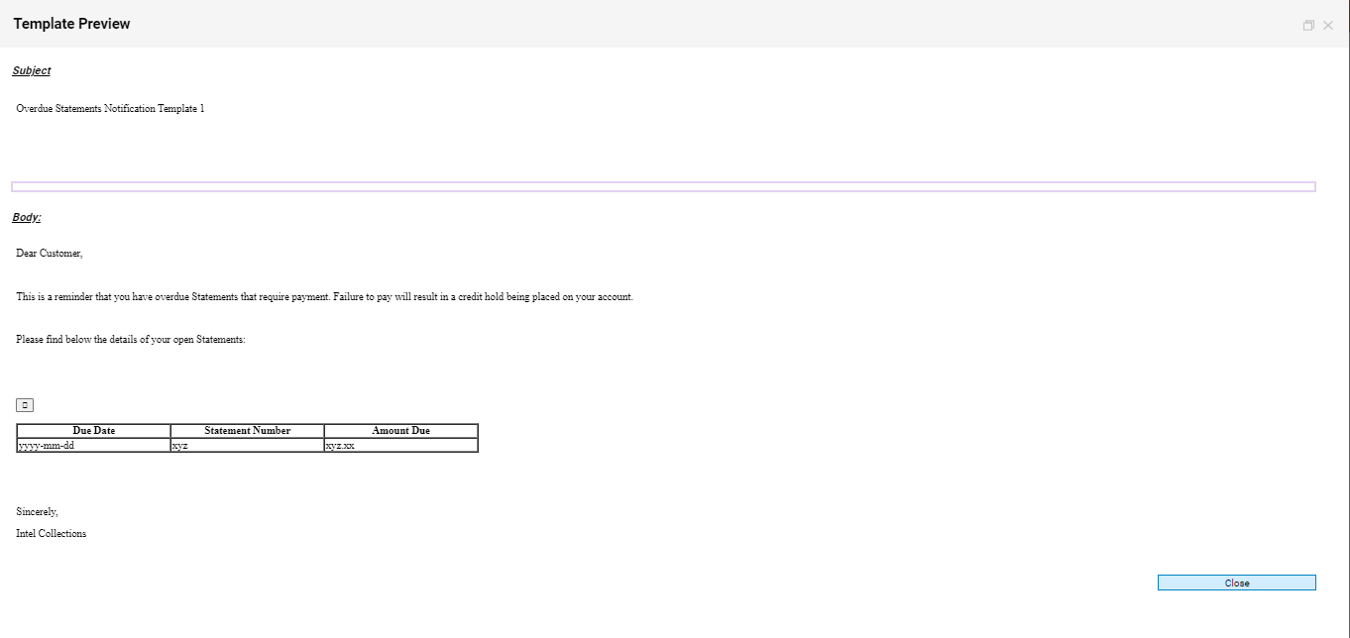

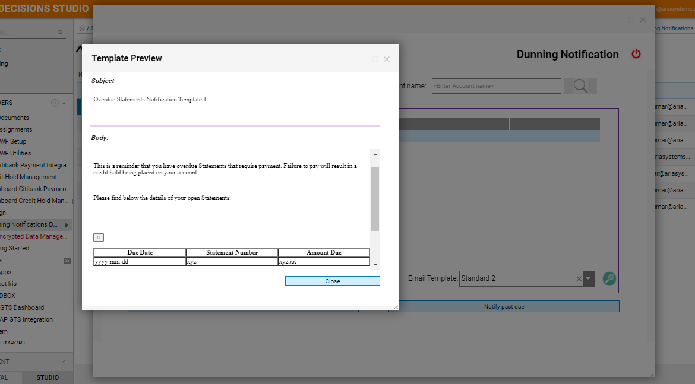

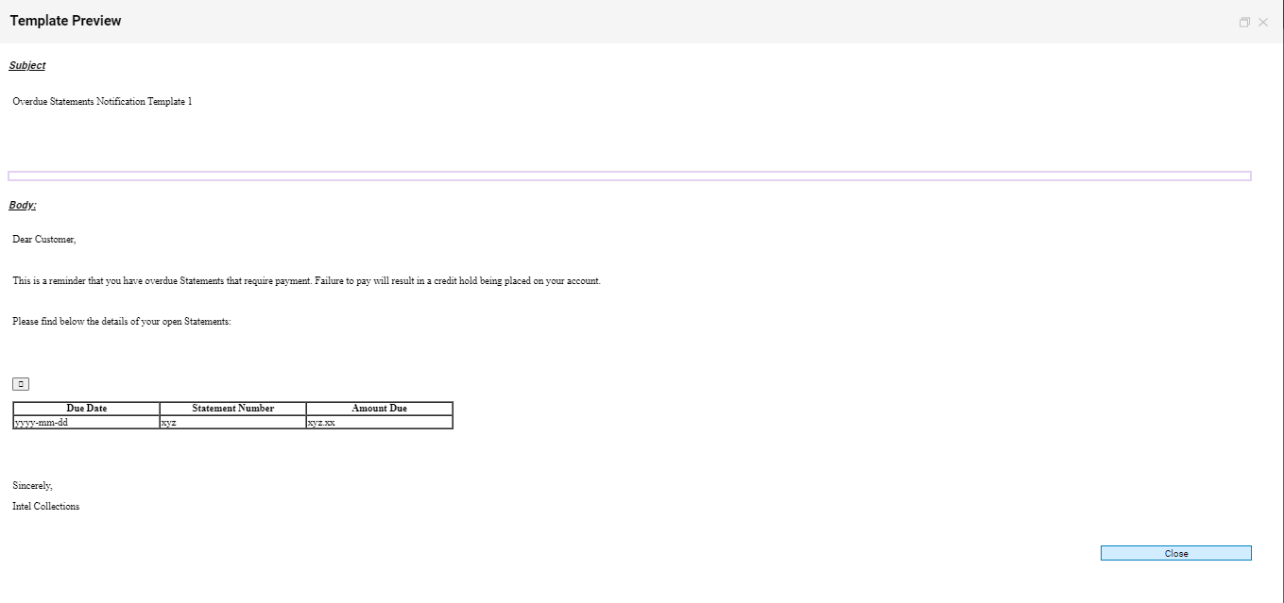

UC# 21 - Dunning template Deactivated











ACCOUNT# 33040563 – Dunning template is Active

